Nitric oxide feedback to ciliary photoreceptor cells gates a UV avoidance circuit

## Abstract

Nitric oxide (NO) produced by nitric-oxide synthase (NOS) is a key regulator of animal physiology. Here we uncover a function for NO in the integration of UV exposure and the gating of a UV-avoidance circuit. We studied UV/violet avoidance mediated by brain ciliary photoreceptors (cPRCs) in larvae of the annelid *Platynereis dumerilii*. In the larva, NOS is expressed in interneurons (INNOS) postsynaptic to cPRCs. UV stimulation of cPRCs triggers INNOS activation and NO production. NO signals retrogradely to cPRCs to induce their sustained post-stimulus activation through an unconventional guanylyl cyclase. This late activation inhibits serotonergic ciliomotor neurons to induce downward swimming. In *NOS* mutants, retrograde signalling, circuit output and UV avoidance are defective. By mathematical modelling, we recapitulate phototransduction and circuit dynamics in wild-type and mutant larvae. Our results reveal how NO-mediated retrograde signalling gates a synaptic circuit and induces short-term memory of UV exposure to orchestrate light-avoidance behaviour.

## Introduction

In nervous systems, synaptic transmission and volume transmission together shape circuit dynamics (Bargmann and Marder, 2013). While synaptic transmission occurs at specialised contact sites, volume transmission is characterised by the delocalised release of diverse diffusive neuromodulators.

Nitric oxide (NO) is one such modulator with unique physical and signalling properties. This free radical synthesized from L-arginine by nitric oxide synthase (NOS) is short-lived and can diffuse across biological membranes (Cudeiro and Rivadulla, 1999; Thomas, 2015). Canonical NO signalling involves the Ca2+/calmodulin-dependent activation of NOS, NO production and diffusion, and the NO-dependent activation of soluble guanylate cyclases (sGC). This can occur cell-autonomously or in other cells leading to cGMP production (Bredt et al., 1990; Hölscher, 1997). Given that NOS activation is calcium dependent and NOS shows neuron-type-specific expression (Aso et al., 2019; Gibbs and Truman, 1998; Mobley et al., 2022; Wildemann and Bicker, 1999), NO action can lead to the activity-dependent modulation of neural circuits at specific sites (Aso et al., 2019; Jacoby et al., 2018; Vielma et al., 2014; Wang et al., 2007) .

In the vertebrate retina, NOS is expressed in amacrine, ganglion and other cells and the actions of NO can be diverse (Cudeiro and Rivadulla, 1999; Jacoby et al., 2018; Wang et al., 2007). For example, defective NO signalling in NOS knockouts leads to a decreased sensitivity of retinal ganglion cells to light stimulation (Wang et al., 2007). In the retina, NO signalling can also involve pathways other than canonical sGC signalling (Jacoby et al., 2018; Tooker et al., 2013; Wei et al., 2012). Due to the complex expression of NOS in vertebrates and the diversity of its functions, it has been challenging to link the neurophysiological effects of NO to signalling mechanisms and behaviour change.

In the *Drosophila* brain, NO signalling is also involved in tuning circuit activity at diverse and specific sites. In the ellipsoid body of the central complex, NO is involved in visual working memory (Kuntz et al., 2017). NO signalling also tunes the dynamics of associative memories in mushroom body circuits. NOS is expressed in PPL1-γ1pedc mushroom-body neurons where it is involved in shortening memory retention while promoting fast memory updating in response to new experiences (Aso et al., 2019).

In the whole organism context, NO signalling has often been studied in diverse marine invertebrates, where NO can regulate larval settlement and metamorphosis (Leise et al., 2001; Locascio et al., 2022; Song et al., 2021; Ueda et al., 2016; Zhang et al., 2012). While NOS-expressing neurons potentially responsible for these effects have been reported (Bishop and Brandhorst, 2007; Locascio et al., 2022), it has not been possible to link these NO-dependent effects on behaviour or life-cycle transitions to neuronal activity and function.

Overall, we still know little about how NO production relates to stimulus conditions, how it shapes circuit activity at specific neuron types, and how NO-dependent modulation relates to behaviour.

To investigate NO function in neural circuit dynamics and behaviour, here we study larvae of the marine annelid model *Platynereis dumerilii* (Ozpolat et al., 2021). *Platynereis* has emerged as a model for systems neuroscience with a toolkit that enables the combination of behavioural analysis and neuronal activity imaging with genetic manipulations. A whole-body synaptic connectome and gene expression atlases are also available and can be integrated with functional approaches in live animals thanks to the cellular-level stereotypy of larvae of the same developmental stage (Ozpolat et al., 2021; Verasztó et al., 2020; Verasztó et al., 2017; Vergara et al., 2021).

Here we uncovered an essential function for NO signalling in larval UV/violet-light avoidance behaviour. In *Platynereis* larvae, UV/violet avoidance is mediated by brain ciliary photoreceptor cells (cPRCs) and is characterised by downward swimming (Verasztó et al., 2018). The cPRCs express a ciliary-type opsin, c-opsin1 (Arendt et al., 2004) that forms a UV-absorbing bistable photopigment with an absorption maximum around 384 nm (Tsukamoto et al., 2017; Veedin Rajan et al., 2021; Verasztó et al., 2018). Upon UV/violet exposure, the cPRC show a characteristic biphasic calcium response that is *c-opsin1* dependent. UV/violet avoidance is also *c-opsin1*-dependent and is defective in *c-opsin1* mutants (Verasztó et al., 2018). Here we show that *Platynereis* *NOS* is expressed in interneurons of the cPRC circuit and is required for UV/violet-avoidance. By combining calcium imaging across the fully-mapped cPRC circuit (Verasztó et al., 2018) with genetic perturbations and mathematical modelling, we describe how NO tunes circuit dynamics through non-synaptic retrograde signalling to cPRCs. This delayed neuroendocrine feedback integrates UV/violet exposure to induce a short-term memory manifested in altered circuit activity and an aversive behavioural response.

## Results

**Nitric oxide synthase is expressed in interneurons of the UV-avoidance circuit**

We identified a single *nitric oxide synthase* (*NOS*) gene in the *Platynereis dumerilii* genome and transcriptome data. Phylogenetic analysis of NOS proteins indicate that *Platynereis* NOS belongs to an orthology group of bilaterian NOS sequences (Figure 1—figure supplement 1). To characterise the expression pattern of *NOS* we used in situ hybridization chain reaction (HCR) and transient transgenesis. In two- and three-day-old larvae, we detected *NOS* expression in four cells (two of them weakly expressing) in the apical organ region (Figure 1D and Figure 1—figure supplement 2). *NOS* was also expressed in the region of the visual eyes (adult eyes) and the pigmented eyespots (Figure 1—figure supplement 2). The four apical organ cells, but not the eyes, were also labelled with a *NOS* reporter construct driving palmitoylated-tdTomato (Figure 1E). This reporter also revealed the axonal projections of these central NOS-expressing neurons. The position and morphology of the four *NOS+* cells allowed us to identify the same four cells as four interneurons (INNOS) in our three-day-old whole-body *Platynereis* volume EM data (Verasztó et al., 2020; Williams et al., 2017) (Figure 1B,C). In the synaptic connectome, the INNOS cells are postsynaptic to the UV-sensory cPRCs and presynaptic to the INRGWa interneurons, which are also cPRC targets (Figure 1C,F). The projections of INNOS cells are segregated into input (dendritic) and output (axonal) compartments, with cPRC inputs occurring on the dendritic part in the dense neurosecretory plexus. INNOS output synapses form in the more ventral projection region (Figure 1—figure supplement 3). INRGWa neurons synapse on the head serotonergic ciliomotor neurons (Ser-h1), which synapse on the prototroch ciliary band and the cholinergic MC ciliomotor neurons (Figure 1C,F) (Verasztó et al., 2017).

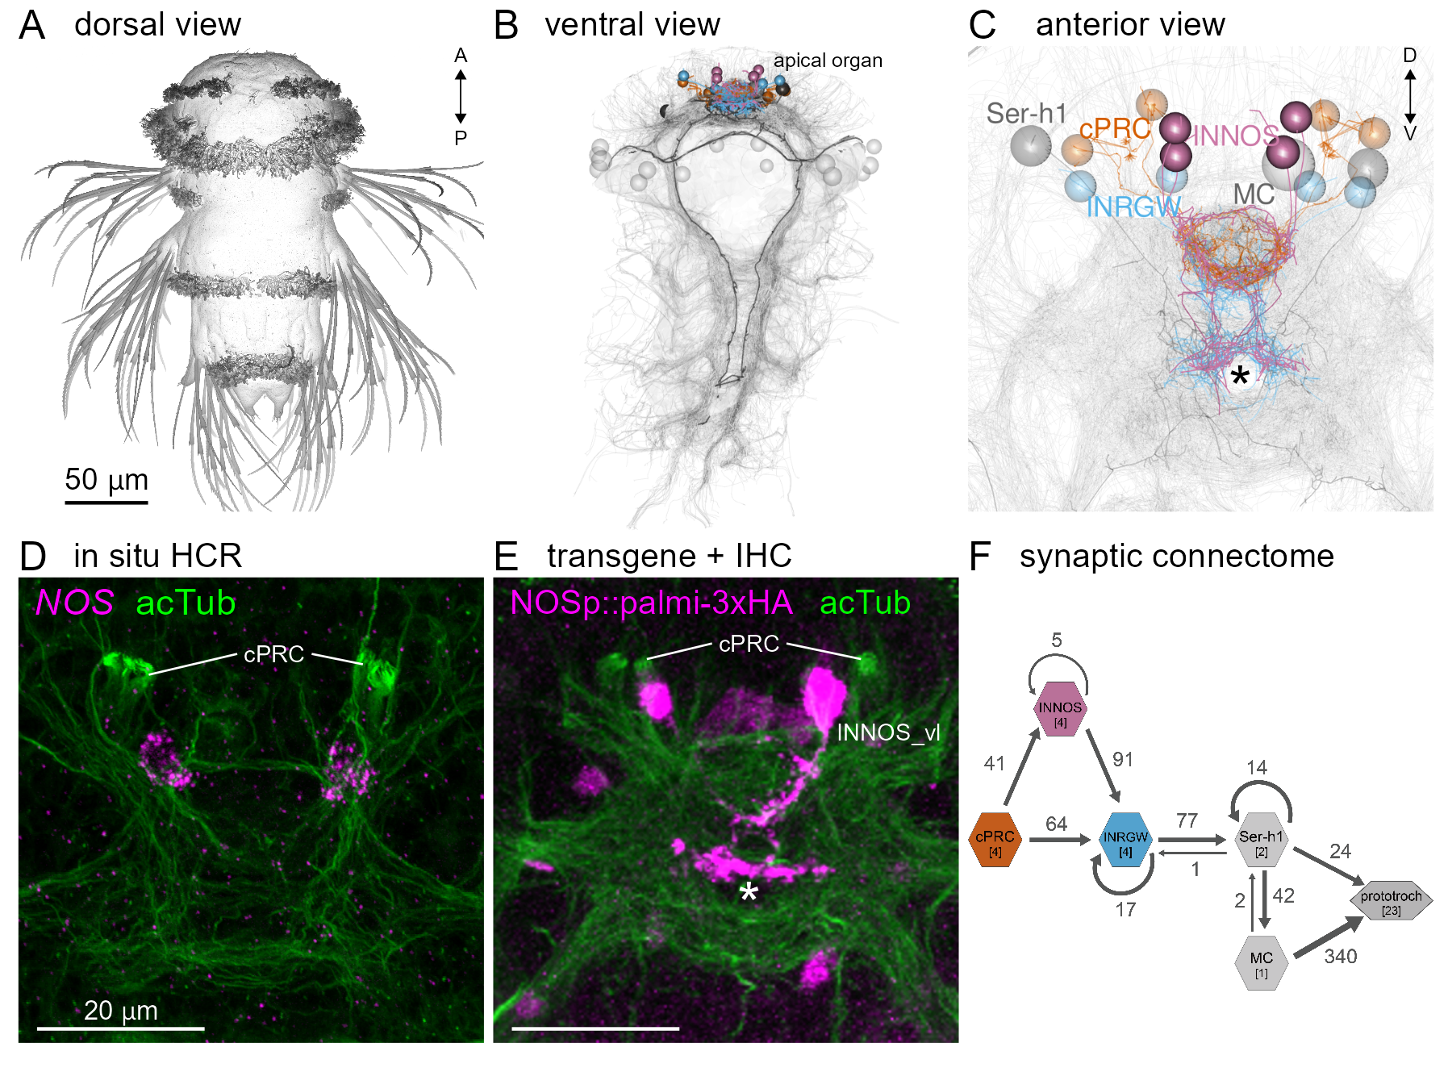

**Figure 1. Identification of NOS-expressing interneurons (INNOS) within the cPRC circuit.** **(A)** Scanning electron microscopy image of a three-day-old *Platynereis* larva. **(B, C)** Volume rendering of the neuron types (cPRC, INNOS, INRGWa, Ser-h1 and MC) in the cPRC circuit reconstructed from a whole-body transmission electron microscopy volume of a three-day-old larva. Neurite skeletons are shown with cell-body positions represented by spheres. Projections of all neurons in the body are shown in grey to highlight the neuropils. The outline of the yolk is also indicated in grey. In B, nuclei positions of the prototroch head ciliary band are shown as grey spheres. **(D)** Expression of the *NOS* gene detected by in situ HCR (magenta) in a two-day-old larva (anterior view). Antibody staining for acetylated α-tubulin (acTub: green) highlights cPRC cilia and the neuropil. **(E)** Expression of a *NOS* reporter (NOSp::palmi-3xHA: magenta) labelled with an anti-HA antibody in a two-day-old larva (anterior view). Antibody staining for acetylated α-tubulin (acTub: green) highlights cPRC cilia and the neuropil. **(F)** Synaptic wiring diagram of the cPRC circuit. Hexagons represent cell groups, with the number of cells per group shown in square brackets. Arrows represent the summed number of synaptic contacts between cell groups. Arrow thickness is proportional to the number of synapses.

**Nitric oxide is produced during UV/violet stimulation of the cPRCs**

The expression of *NOS* in the INNOS interneurons in the cPRC circuit suggests that NO signalling may be involved in UV/violet-avoidance. To test this, first we asked whether NO is produced during UV/violet stimulation of the larvae. We injected the fluorescent NO-reporter DAF-FM into zygotes and imaged two-day-old larvae while exposing the region of cPRC cilia to 405 nm violet light. To mark cell outlines, we coinjected mRNA encoding a red-fluorescent reporter (RGECO), allowing the identification of the cPRCs. Following light stimulation in the region of the ramified cilia of the cPRCs, we detected an increase in DAF-FM fluorescence in the anterior neurosecretory neuropil, the region of INNOS projections. This increase did not occur in larvae where we illuminated a control area (Figure 2).

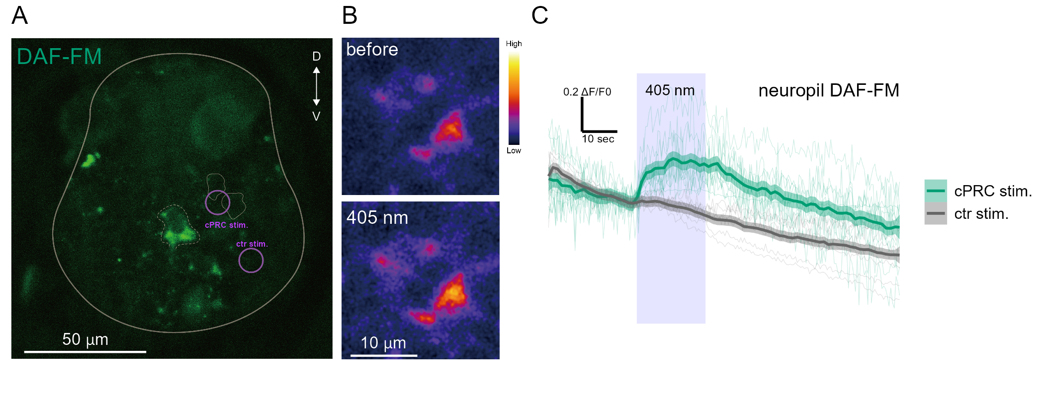

**Figure 2. NO produced by UV/violet stimulation to cPRCs.** **(A)** DAF-FM fluorescence in the region of the neurosecretory neuropil. The white line indicates the outline of the larva. The dashed line corresponds to the area where fluorescence was quantified. Circles indicate the location of cPRC and control stimulation. cPRCs are marked by thin lines. **(B)** Changes in DAF-FM fluorescence before and during 405 nm light stimulation. **(C)** Changes in DAF-FM fluorescence over time during 405 nm stimulation of the cPRCs (green) or a control area (ctr: gray). The purple box indicates the duration of 405 nm stimulation. Individual traces normalized (ΔF/F0) are shown as thin lines. Thick lines show the mean value with 0.95 confidence intervals. N = 9 larvae for control and 11 for cPRC stimulation.

**Nitric oxide signalling mediates UV-avoidance behaviour**

We next tested whether NO signalling regulates UV/violet avoidance. To achieve this, we generated two *Platynereis* *NOS* knockout lines with the CRISPR/Cas9 method. We recovered two deletions (NOSΔ11/Δ11 and Δ23/Δ23), both frame-shift mutations leading to an early stop codon and thus likely representing null alleles (Figure 3—figure supplement 1A). We could establish a homozygous line for both mutations indicating that NOS is not an essential gene in *Platynereis*. To quantify UV avoidance, we recorded the trajectories of freely swimming wild type and mutant larvae in vertical columns, illuminated laterally from two opposite sides with 395 nm UV light (Figure 3A and Figure 3—figure supplement 1B). As previously shown, wild-type larvae swim downward following non-directional UV/violet light stimulation (Verasztó et al., 2018). In contrast, both two- and three-day-old homozygous *NOS*-mutant larvae showed a strongly diminished UV-avoidance response (Figure 3A, B and Figure 3—figure supplement 1B,C). This phenotype is similar to the defective UV-avoidance of *c-opsin1* mutant larvae (Verasztó et al., 2018) and reveals a requirement for NOS in UV-avoidance behaviour. Wild type but not mutant larvae also showed an increase in swimming speed under UV light that may be due to downward swimming trajectories (swimming in the direction of gravity) (Figure 3B and Figure 3—figure supplement 1C). We also tested directional phototaxis, by exposing larvae to 480 nm directional collimated light from the top of the column. Three-day-old but not two-day-old *NOS*-mutant larvae also showed reduced phototactic behaviour, suggesting a function for *NOS* in the visual eyes that mediate three-day-old phototaxis (Randel et al., 2014) (Figure 3D and Figure 3—figure supplement 1G).

To distinguish between an acute and developmental function of NOS in light responses, we next tested larvae exposed to the NOS inhibitor L-NAME. Larvae incubated for 5 min in 0.1 mM or 1 mM L-NAME showed a dose-dependent inhibition of UV avoidance. In contrast, phototaxis was not affected (Figure 3C, E). Overall, our results indicate an acute requirement for NOS signalling in UV-avoidance and a possible indirect, developmental role in the visual system, reminiscent of the function of NO signalling in *Drosophila* eye development (Gibbs and Truman, 1998).

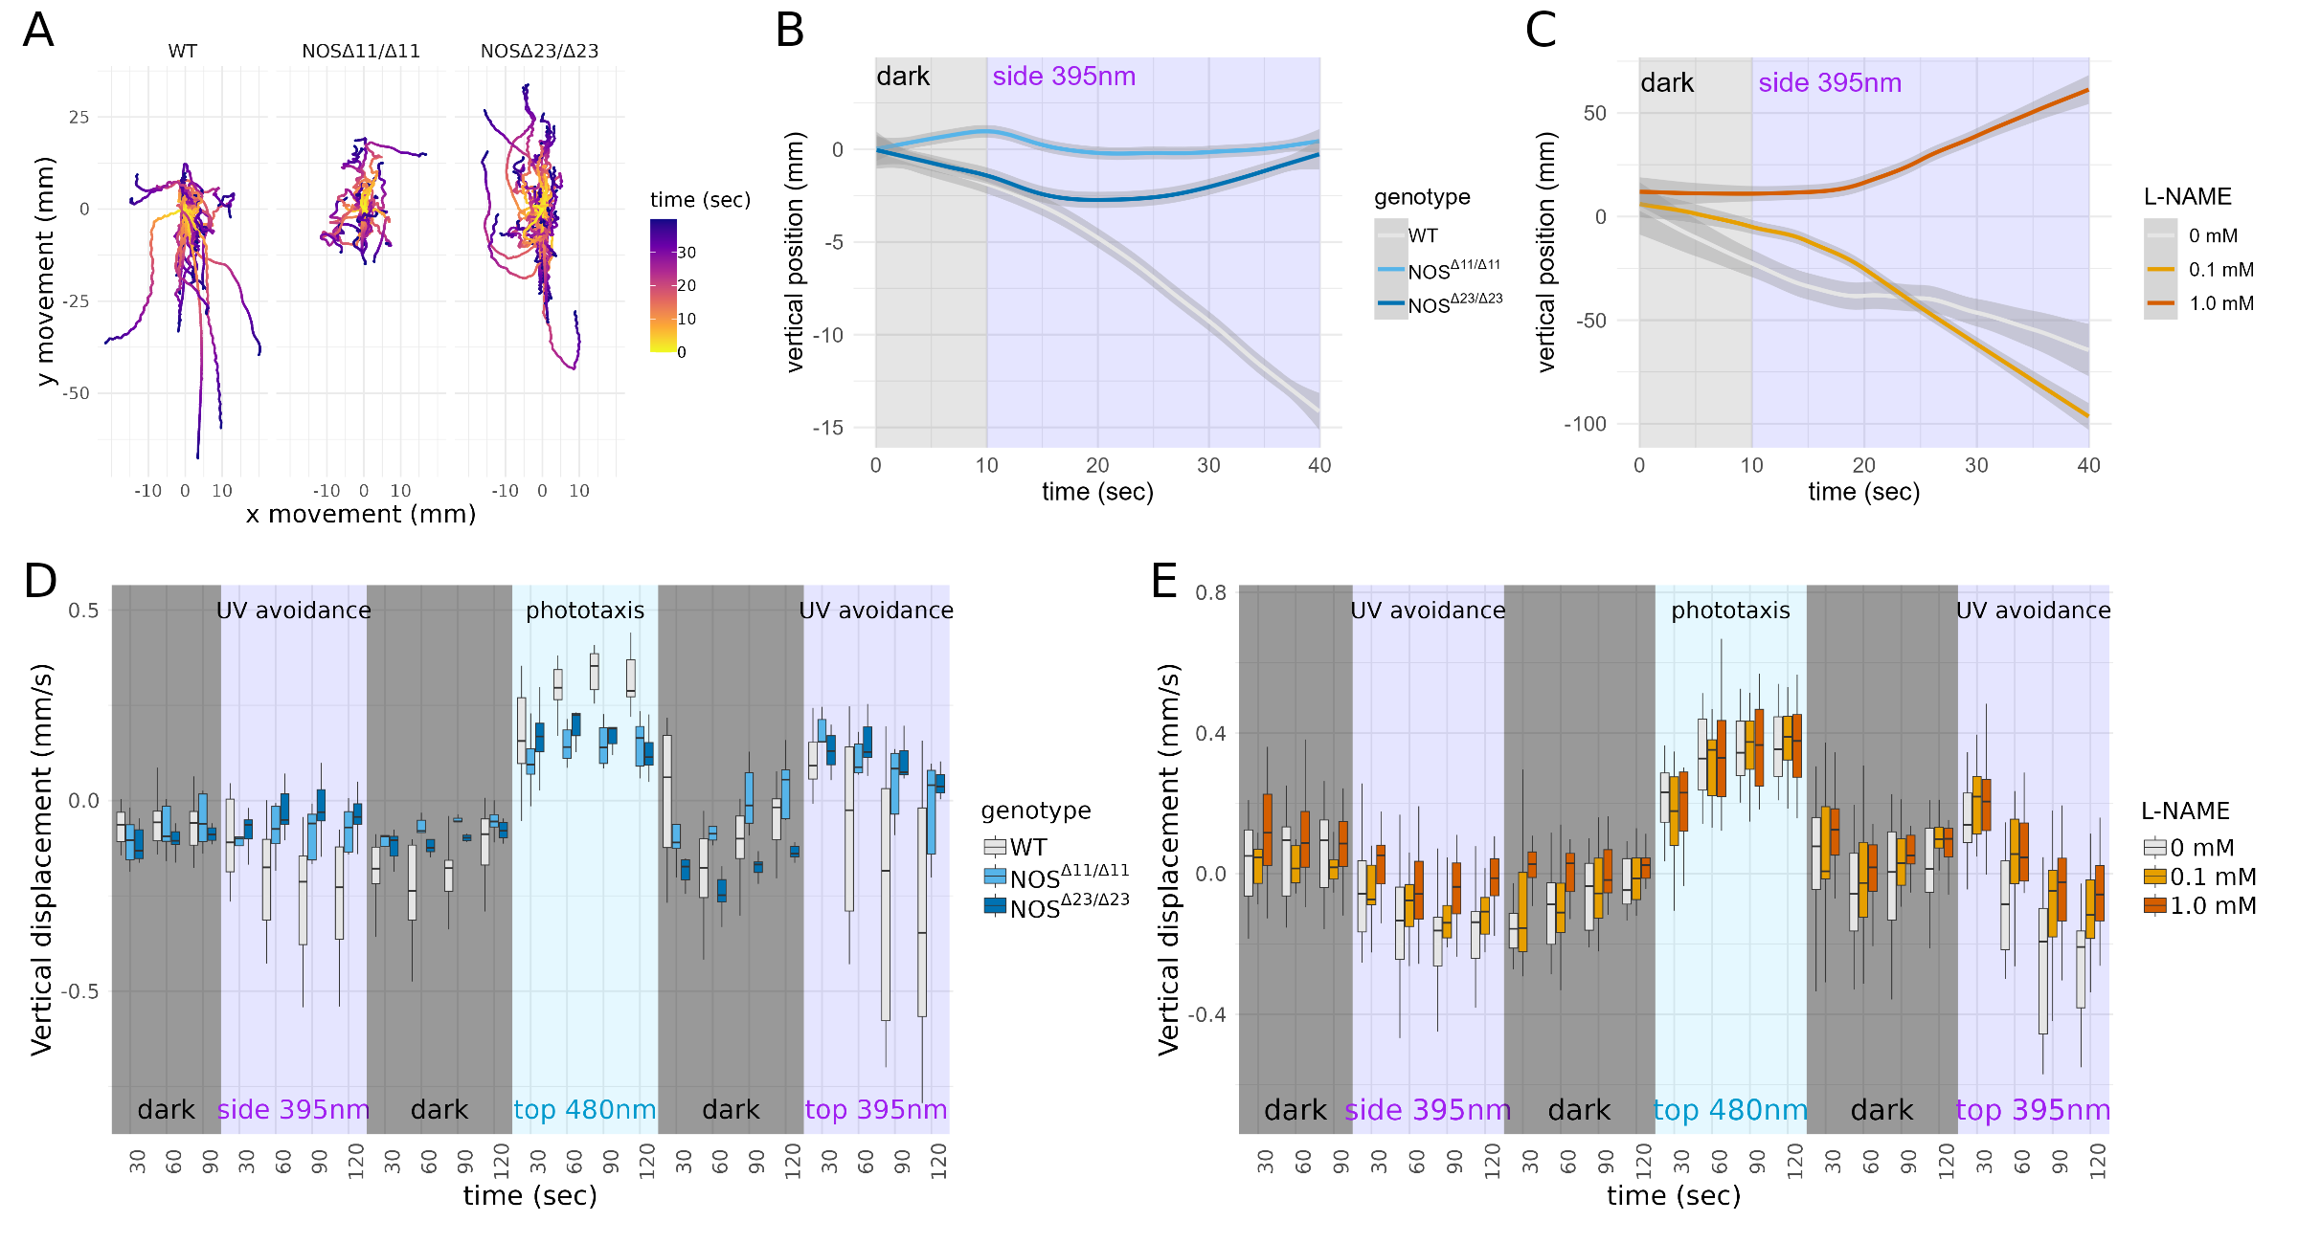

**Figure 3. NOS is required for UV avoidance in *Platynereis* larvae.** **(B)** Swimming trajectories of wild type (WT, n=32) and NOS mutant (NOSΔ11/Δ11, n=26 and NOSΔ23/Δ23, n=47) three-day-old larvae. All trajectories start at 0 x and y position and time 0 corresponding to 10 sec after the onset of 395 nm stimulation from the side. **(B)** Vertical position of batches of wild type and mutant three-day-old larvae over time under 395 nm UV stimulation. The starting position of each larval trajectory was set to 0. **(C)** Vertical position of batches of control and L-NAME-treated (0.1 and 1 mM) three-day-old larvae over time under 395 nm UV stimulation. The starting position of each larval trajectory was set to 0. **(D)** Vertical displacement in 30 sec bins of wild type and mutant (NOSΔ11 and NOSΔ23) three-day-old larvae stimulated with 395 nm light from the side, 488 nm light from the top and 395 nm light from the top. **(E)** Vertical displacement in 30 sec bins of control and L-NAME-treated (0.1 and 1 mM) three-day-old larvae stimulated with 395 nm light from the side, 488 nm light from the top and 395 nm light from the top.

**NO retrograde signalling tunes cPRC responses to UV/violet stimulation**

To investigate how NO signalling alters the dynamics of the cPRC circuit, we carried out calcium imaging experiments. We ubiquitously expressed the calcium sensor GCaMP6s in larvae and imaged calcium signals during 405 nm stimulation of the cPRCs. As we have shown previously, a 20-sec local stimulation of cPRC cilia led to a transient increase in cPRC calcium levels, followed by a transient decrease (Verasztó et al., 2018). After ~20-sec, calcium levels in cPRCs were raising again, reaching higher levels than at the start of the stimulus – a response that may involve depolarisation (Figure 4A, B). This activation phase occurs after the 20 sec stimulation period and is likely due to a delayed neuroendocrine feedback (Verasztó et al., 2018). To determine whether NO mediates such a feedback, we repeated the experiment in *NOS*-mutant larvae. While we detected the initial activation phase followed by inhibition, in homozygous *NOS*-mutants for both CRISPR alleles this was not followed by delayed activation. Instead, calcium levels dropped to a low steady-state level (Figure 4A, B). We thus identified a requirement for NO signalling in the late-phase activation of cPRCs.

**Two unconventional guanylyl cyclases are expressed in the cPRCs**

We aimed next to identify the NO receptor in the cPRCs. NO generally acts via soluble guanylate cyclases (sGC), belonging to the guanylate cyclase family with a CYC domain (PFAM domain: PF00211). NO binding to the heme group of sGC leads to increased cyclic guanosine monophosphate (cGMP) production. Analysis of sGCs in *Platynereis* indicated that these genes are not expressed in any of the cells of the cPRC circuit (Verasztó et al., 2017). Recently, Moroz and coworkers reported an atypical but widely conserved family of guanylyl cyclases with a NIT (nitrite/nitrate sensing) domain (PF08376) (NIT-GC) as potential mediators of NO signalling (Moroz et al., 2020). To identify NIT-GCs in *Platynereis*, we searched transcriptome resources and retrieved 15 potential NIT-GC homologs (Figure 4—figure supplement 1 and 2). To analyse the relationship of these sequences to metazoan NIT-GCs, we retrieved protein sequences with a CYC domain from the transcriptome and genome databases of 45 metazoan and 2 choanoflagellate species. We carried out cluster analysis and did phylogenetic reconstruction on a group of membrane-bound guanylyl cyclases with sGCs as an outgroup. In agreement with Moroz et al. (Moroz et al., 2020), we found a group of GCs with NIT domains with representatives in placozoans, cnidarians, some ecdysozoans, echinoderms, and lophotrochozoans. The 15 *Platynereis* sequences belonged to several deeply diverged clades in the phylogenetic tree (Figure 4—figure supplement 1 and 2).

To characterise the expression of NIT-GCs, we used previously published spatially mapped single-cell transcriptome data (Achim et al., 2015; Williams et al., 2017). Among the 15 NIT-GCs, two showed high and specific expression in the cPRCs and one was expressed in the INNOS cells (Figure 4—figure supplement 2). In the single-cell data, we could identify the cPRCs by the specific expression of *c-opsin1* and the *pedal-peptide2 neuropeptide precursor* (*MLD proneuropeptide*), previously described cPRC markers (Arendt et al., 2004; Williams et al., 2017) (Figure 4—figure supplement 3A). The INNOS cells were identified by NOS expression and spatial mapping in the brain (Achim et al., 2015). We decided to focus on two NIT-GCs expressed in the cPRCs and with a full-length sequence, *NIT-GC1* and *NIT-GC2*. To confirm the single-cell data, we first carried out in situ hybridisation chain reaction (HCR) with probes for *NIT-GC1* and *NIT-GC2* mRNA. Both genes were specifically expression in the four cPRCs, as confirmed by co-labeling with an acetylated α-tubulin antibody and with an HCR probe against *pedal peptide 2/MLD proneuropeptide* (Figure 4C, D and Figure 4—figure supplement 3A-C). To analyse the subcellular localisation of NIT-GC1 and NIT-GC2 at the protein level, we raised and affinity-purified polyclonal antibodies against a specific peptide sequence from both proteins. In immunostainings, we found that NIT-GC1 was localise to the region corresponding to the axonal projections of the cPRCs in the anterior neurosecretory plexus (Figure 4E). Co-immunostaining with the rabbit NIT-GC1 antibody and a custom rat antibody raised against *Platynereis* NOS revealed the localisation of both proteins in dots in the neurosecretory neuropil (Figure 4—figure supplement 3D). In contrast, NIT-GC2 specifically labelled the ramified sensory cilia of the cPRCs (Figure 4F). These different subcellular localisations suggest that the two NIT-GCs are involved in different intracellular signalling processes in the ciliary and axonal regions of the cPRCs.

**NIT-GC1 produces cGMP in an NO-dependent manner**

To further characterise these atypical guanylyl cyclases, we focused on NIT-GC1 and carried out in vitro experiments. In bacteria, NIT domains are thought to regulate cellular functions in response to intra- or extracellular nitrate and nitrite. NIT-GC1 has a NIT domain and a highly conserved cyclase domain that is expected to catalyse cGMP synthesis (Figure 4G). The NIT domain may render NIT-GC1 dependent on NO signals. To test this, we co-expressed the cGMP indicator Green cGull (Matsuda et al., 2016) and NIT-GC1 in cultured COS-7 (monkey kidney) cells, a cell line with minimal endogenous sGC activity (Matsuda et al., 2016). For balanced expression, we used a single plasmid with the two open-reading frames separated by the 2A self-cleaving peptide (Figure 4H). Application of the NO donor SNAP lead to increased Green cGull fluorescence, an effect we did not observe when cells were exposed to DMSO or when Green cGull was expressed alone (Figure 4I-K). To test whether this effect is dependent on the NIT domain, we also tested a deletion construct of NIT-GC1 lacking the NIT domain (Figure 4G). Cells expressing this construct and Green cGull did not show an increased fluorescence of the cGMP reporter when exposed to SNAP (Figure 4L). These results indicate that NIT-GC1 is able to catalyse cGMP production in an NO-dependent manner and this function requires the NIT domain. These results establish NIT-GC1 as a biochemical sensor of NO or its derivatives.

**NIT-GC1 is required for NO-mediated retrograde signalling to cPRCs during the UV response**

To test the in vivo function of NIT-GC1 and NIT-GC2 in cPRC responses, we combined calcium imaging with morpholino-mediated knockdowns. We used two translation-blocking morpholinos for each *NIT-GC* gene and tested knockdown efficiency by immunostaining injected animals with the NIT-GC1 and NIT-GC2 antibodies (Figure 4—figure supplement 3E,F). For both genes, the morpholinos led to a strong reduction in the respective antibody signal, confirming efficient knockdown and antibody specificity.

In NIT-GC1 morphant larvae, the delayed activation of cPRCs following 405 nm stimulation did not occur (Figure 4M). This phenotype is similar to the phenotype of *NOS* mutants suggesting that NIT-GC1 acts as the NO sensor in cPRCs to drive their delayed activation. This could occur via increased cGMP production and the opening of a cyclic-nucleotide-gated ion channel (CNG) specific to cPRCs (Tosches et al., 2014). NIT-GC2 morphant larvae, in contrast, showed a step-up increase in calcium following light stimulation (Figure 4N). The calcium signal decayed during stimulation and was off after light off. These data support an essential role for ciliary-localised NIT-GC2 in suppressing cPRC calcium following its transient rise at stimulus onset. Overall, these knockdown experiments revealed different signalling mechanisms for the two NIT-GCs that may be due to their different subcellular localisations.

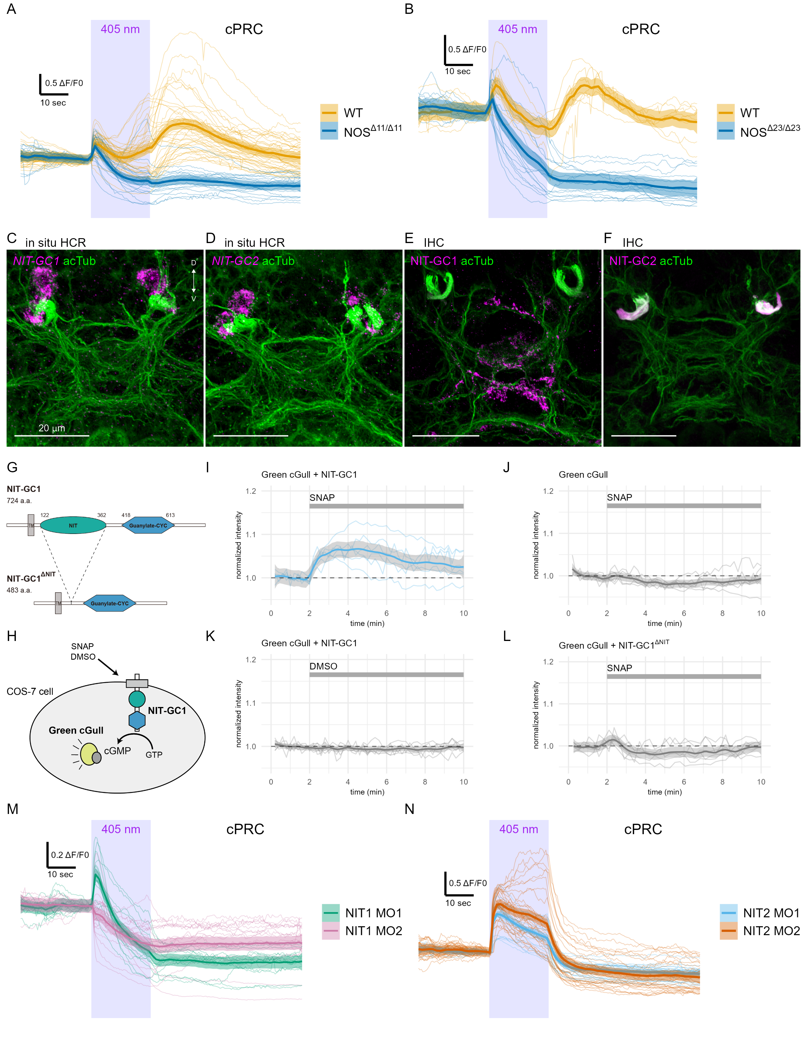

**Figure 4. NOS and two NIT-GCs shape calcium signals during cPRC UV/violet response.** **(A, B)** GCaMP6s signals in cPRCs in wild type and *NOS* mutant (A, NOSΔ11/Δ11, B, NOSΔ23/Δ23) larvae during 405 nm light stimulation. **(C, D)** In situ HCR for (C) *NIT-GC1* and (D) *NIT-GC2* (magenta) in three-day-old *Platynereis* larvae. Larvae were co-stained with an antibody against acetylated α-tubulin to label cPRC cilia and the neuropil (green). **(E, F)** Immunostaining for (E) NIT-GC1 and (F) NIT-GC2 (magenta), co-stained for acetylated α-tubulin (green). **(G)** The domain structure of *Platynereis* NIT-GC1 and the truncated NIT-GC1ΔNIT protein lacking the NIT domain. A predicted transmembrane region (TM) is shown in grey. **(H)** Schematic of the cell-based assay to detect cGMP production following the addition of an NO donor SNAP or DMSO as control. **(I-L)** Green cGull fluorescence over time for the four conditions tested. Individual responses and their mean with 0.95 confidence interval are shown (n > 6 cells). Intensities are normalized (ΔF/F0). The indicated chemicals were added at 2 min after the start of imaging (grey bars). **(M, N)** GCaMP6s signals in cPRCs in (M) NIT-GC1 and (N) NIT-GC2 morphant larvae during 405 nm light stimulation. Individual responses and their mean with 0.95 confidence interval are shown.

**NO signalling shapes the dynamics of the cPRC circuit**

To investigate how NO and NIT-GC signalling influence the dynamics of the cPRC circuit, we imaged calcium signals from postsynaptic neurons in wild type, mutant and morphant larvae. We were able to image the activity of all neurons in the cPRC circuit (INNOS, INRGWa, Ser-h1 and MC). The MC cell was identified based on its position and intrinsic activity (Verasztó et al., 2017). To unambiguously identify all other cells from which we recorded calcium signals, we developed an on-slide immunostaining method (Figure 5—figure supplement 1A). We used the cell-specific antibody markers against RYamide (INNOS) (Figure 5—figure supplement 1B-D), RGWamide (INRGWa) and serotonin (Ser-h1) (Conzelmann et al., 2011) to immunostain agar-embedded larvae following calcium imaging. Based on the position of the nuclei, we could correlate live and fixed samples at a single-cell precision (Figure 5A,B). Due to the stereotypy of the larvae, we could also identify neurons based on their position and calcium activity in activity-correlation maps (Figure 5C).

We first quantified the responses of the INNOS and INRGWa interneurons during 405 nm stimulation of the cPRCs. In both wild type and *NOS*-mutant larvae, INNOS cells showed an increase in calcium during stimulation (Figure 5D). In contrast, the INNOS response was flat or slightly negative in NIT-GC2 morphant larvae (Figure 5E) revealing an essential role for NIT-GC2-mediated cPRC suppression in INNOS activation. INRGWa cells were initially inhibited during cPRC stimulation, followed by a delayed activation paralleling the second activation phase of cPRCs. This late INRGWa response was lacking in *NOS*-mutants (Figure 5F). In NIT-GC2 morphants, INRGWa cells showed a transient increase in calcium that decayed after light off and a delayed activation was not present (Figure 5G).

Next, we imaged calcium signals from Ser-h1 and MC neurons in wild type and *NOS* mutant larvae. Ser-h1 cells showed an activation profile that correlated with cPRC activity, including a reduction in calcium during stimulation followed by rebound, a response that was defective in *NOS* mutants (Figure 5I). MC cells showed sustained activation, including a late-phase that was lacking in *NOS* mutants (Figure 5I). These data suggest that during 405 nm stimulation the Ser-h1 cells are inhibited and MC cells are activated, and this regulation is NO-dependent. This pattern is expected to inhibit ciliary activity in the prototroch but not in the other ciliary bands, triggering NO-dependent downward swimming.

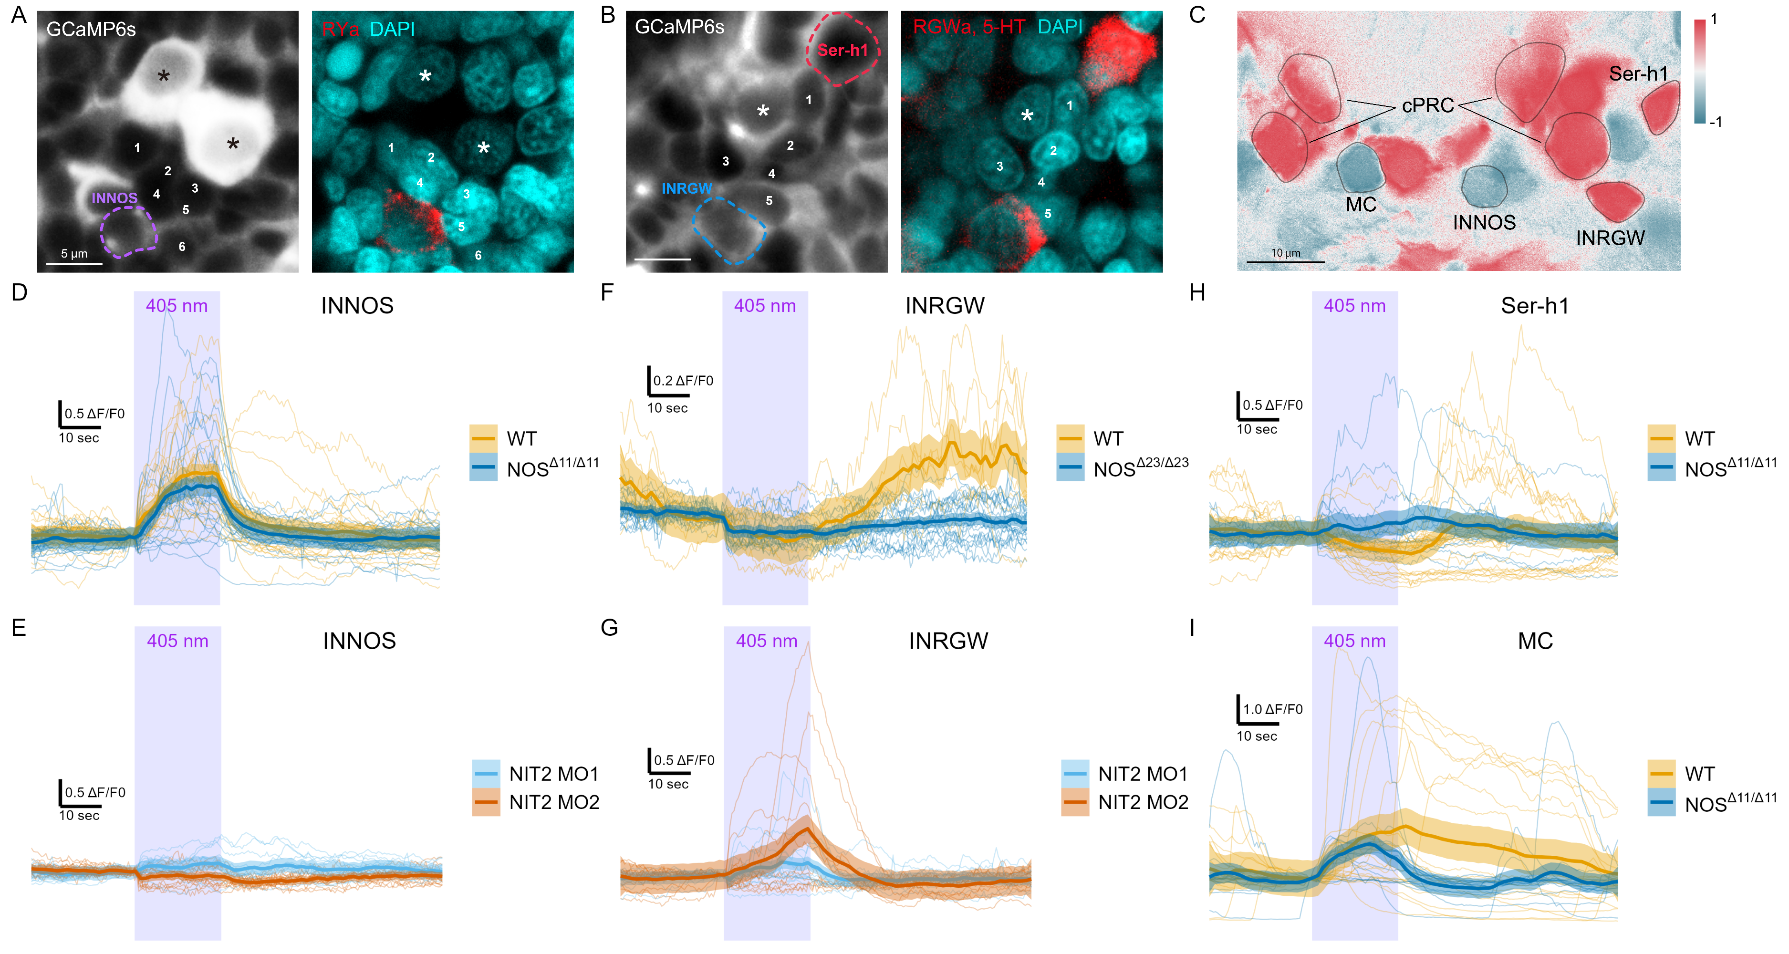

**Figure 5. NOS- and NIT-GC2-dependent dynamics of the cPRC circuit.** **(A, B)** GCaMP6s imaging from cPRCs and INNOS cells (left panels) followed by on-slide immunostaining for (A) RYamide to label INNOS and (B) RGWamide+serotonin to label INRGWa and Ser-h1 (red). Nuclei are stained with DAPI (cyan). Asterisks indicate cPRC nuclei. Numbers mark the same cells in the GCaMP and immunostaining images matched by position. **(C)** Correlation map of neuronal activity of the cPRCs, INNOS, INRGWa, Ser-h1 and MC neurons. **(D)** GCaMP6s fluorescence in INNOS cells in wild type (WT) and NOSΔ11/Δ11 mutant larvae during 405 nm stimulation of the cPRC cilia. **(E)** GCaMP6s fluorescence in INNOS cells in NIT-GC2 morphant larvae during 405 nm stimulation. **(F)** GCaMP6s fluorescence in INRGWa cells in wild type and NOSΔ23/Δ23 mutant larvae during 405 nm stimulation. **(G)** GCaMP6s fluorescence in INRGWa cells in NIT-GC2 morphant larvae during 405 nm stimulation. **(H, I)** GCaMP6s fluorescence in (H) Ser-h1 cells and (I) the MC cell in wild type and NOSΔ11/Δ11 mutant larvae during 405 nm stimulation.

**Mathematical modelling of cPRC-circuit dynamics**

To further analyse the dynamics of responses to UV light and formally describe cPRC phototransduction, synaptic connections and NO retrograde signalling, we developed a mixed cellular-circuit-level mathematical model. We used our Ca2+ imagining data of cPRC, INNOS and INRGWa cells collected in wild type, *NOS* knockout, and *NIT-GC2* morphant larvae to formulate assumptions that are the basis of the proposed model.

We model a direct c-opsin1-dependent response to UV leading to the initial rise in Ca2+ levels. The mechanism of this signal is not known but may include Gα and Gβ signalling, CNGAα channel activation or other pathways. We further assume that in cPRC cells, Ca2+ levels increase with cGMP. We model a decrease in cGMP and Ca2+ levels due to a NIT-GC2-dependent pathway (Figre 6A). The effect of NO in cPRC cells is captured by another term that describes a NIT-GC1 and NO-dependent increase in cGMP. Based on the synaptic connectome, we infer a feedforward coupling between cPRC cells and INNOS and INRGWa cells. The proposed synaptic coupling is UV-dependent, decays linearly and is suppressed in NIT-GC2 morphants (Figure 6A).

In the INNOS cells, we assume that excitatory synaptic input from cPRC (or rebound from tonic inhibition) leads to a rise in Ca2+ leading to NO production via NOS. This input is NIT-GC2-dependent. In the INRGWa cells, we model a decrease in Ca2+ based on an inhibitory UV-dependent synaptic signal from the cPRCs. We further assume the existence of direct excitatory coupling between cPRC Ca2+ levels and INRGWa Ca2+ to account for the late effects of cPRC on INRGWa (Figure 6A). The UV-dependent and Ca2+-dependent signals may be mediated by different transmitters released by cPRCs during distinct phases of their activation cycle. In addition, we assume a direct inhibitory coupling between INNOS Ca2+ and INRGWa Ca2+. Finally, in all variables, we assumed a linear decay and constant production to set a steady state (Figure 6A). Since the aim of the model is to capture the normalised fluorescence data, the model is nondimensionalised. UV stimulation is modelled as a square pulse. To find model parameters producing an output fitting the experimental data we employed a global optimisation method known as a genetic algorithm (GA).

Through this optimisation procedure, we found parameters that gave a very good fit to our experimental data under all conditions. We could fit to mean Ca2+ values but also individual calcium transients (Figure 6B, Figure 6–figure supplement 1). Our model only includes a minimal set of parameters and assumptions of interactions that are required to describe the dynamics of cPRC, INNOS and INRGWa in wild type and loss-of-function conditions (Figure 6A, B). The model highlights that cPRC phototransduction employs distinct pathways that operate on different time scales and differentially influence cPRC Ca2+ levels. The coupling between cPRCs and interneurons also requires different signalling mechanisms, either through distinct neurotransmitters or receptors expressed in the different cells.

To identify possible molecular pathways, we analysed single-cell transcriptome data for cPRC, INNOS and INRGWa identified by spatial mapping (Achim et al., 2015) and unique marker genes (Williams et al., 2017). In cPRCs, we found transporters and synthetic enzymes indicating cholinergic, glutaminergic, glycinergic, GABAergic and adrenergic neurotransmission (Figure 6C). For each neurotransmitter, we also found receptor-encoding genes expressed in INNOS and INRGWa (Figure 6C). The two types of interneurons often expressed different subunits or types of these receptors, indicating differential signalling (Figure 6C).

Based on these data, our experimental results and the mathematical model, we assembled a minimal phototransduction and circuit diagram. The components for which experimental data are available are shown in bold. Other potential molecular players are also indicated (Figure 6D).

To generate new insights from the model, we asked how the duration and intensity of UV stimulation influences signalling output, measured as the magnitude, duration and time to maximum of the NO-dependent Ca2+ signal in the cPRCs. The model allowed us to test a large number of conditions that would not have been feasible in single-larva experiments. We found that the onset, magnitude and duration of the NO-dependent signal scales with stimulus intensity and duration (Figure 6–figure supplement 2). This suggests an integratory function of NO signalling that tunes circuit output to the strength of UV exposure.

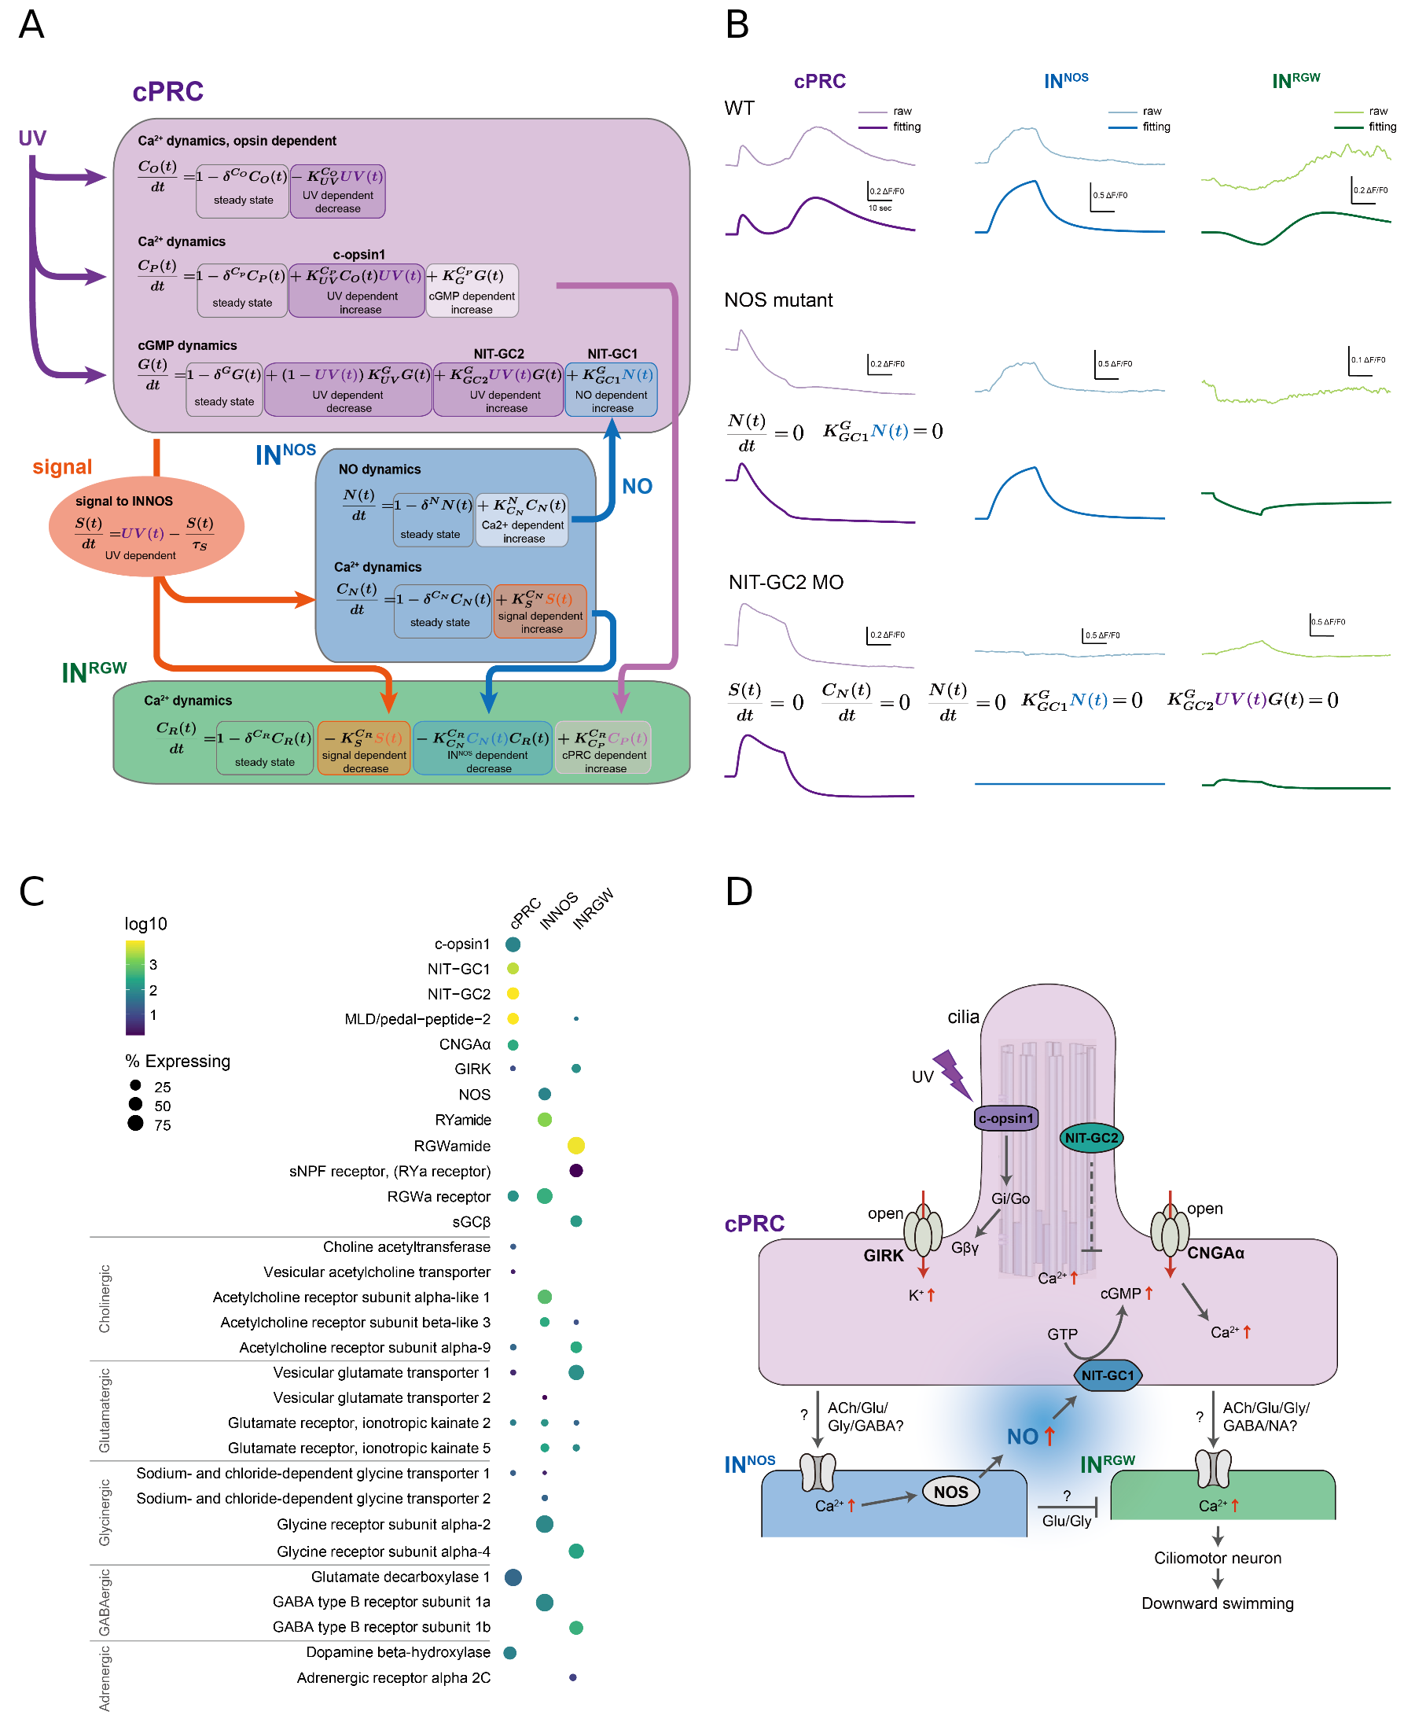

**Figure 6. Mathematical modelling of cPRC circuit dynamics during UV stimulation and potential signalling mechanisms.** **(A)** Diagram for **(B)** **(C)** Dot plot of genes (columns) expressed in three types of cells (rows) in the cPRC circuit using single cell RNA-Seq. The size of the dots is expressed in proportion to the percentage of cells expressing that gene relative to all cells. The colours represent the normal logarithm of the number of transcripts in the cells expressing the gene. **(D)** Schematic diagram of the signalling pathway of the cPRC circuit, focusing on the NO feedback.

## Discussion

Our work revealed an essential role for NO-mediated signalling in driving UV/violet avoidance behaviour in larval *Platynereis*. NO, produced by postsynaptic INNOS interneurons, signals retrogradely to presynaptic cPRCs via NIT-GC1 leading to delayed and sustained cPRC activation. This late-phase activation of the photoreceptors drives circuit output through projection interneurons and ciliomotor neurons. In the cPRC circuit, synaptic connectivity alone is thus not sufficient to account for circuit dynamics and behavioural change, as documented in other circuits (Bargmann and Marder, 2013; Imambocus et al., 2022).

**Localised NO signalling in the neurosecretory plexus**

NO is a free radical with a millisecond-to-second half life and thus a limited signalling range. In neuronal signalling, NOS is often localized to neurites (Kuntz et al., 2017) at close proximity to sGC at synapses (Burette et al., 2002; Garthwaite, 2015). In the cPRC circuit, NOS is localised to the dendritic compartment of INNOS cells where also cPRC postsynaptic sites occur. NIT-GC1, the target of NO signalling is localised to cPRC projections. NO-mediated retrograde signalling thus likely occurs in the neurosecretory plexus where NOS- and NIT-GC1-containing projections are in close proximity and where we detected NO production following UV stimulation. In contrast, INNOS to INRGWa synapses occur outside the neurosecretory plexus in the ventral brain neuropil.

Compartmentalised signalling also occurs in peptidergic modulatory systems and can enable selective network activity during specific behaviours. In the UV-avoidance circuit of *Drosophila* larvae, a peptidergic hub neuron Dp7 links UV-sensory neurons (v’td2) and motor circuits. Dp7 expresses an an insulin-like peptide Ilp7 that is required for acute and sustained UV avoidance. Ilp7 signalling occurs at a functionally and morphologically distinct dendritic compartment of Dp7, segregated from other sensory-motor pathways involving Dp7 (Imambocus et al., 2022).

**Functional diversity of NIT-GCs**

NO signalling is commonly mediated by sGCs. We identified 12 sGCs in *Platynereis*, but none of these is expressed in the cPRC based on the available scRNAseq data. Instead, we identified an unconventional cPRC-expressed NIT-domain containing GC, NIT-GC1 as the mediator of NO retrograde signalling. In an in vitro assay, we could show that NIT-GC1 can produce cGMP following the addition of an NO donor and that this activity requires the NIT domain.

NIT domains were first identified in bacteria and animal NIT-GCs have only recently been reported (Moroz et al., 2020; Shu et al., 2003). Bacterial NIT domains regulate cellular functions in response to changes in extracellular and intracellular nitrate and nitrite concentrations (Camargo et al., 2007). NO is readily converted to nitrate and nitrite (Garthwaite, 2015; Möller et al., 2019; Santos et al., 2011) and these molecules accumulate in placozoans and cnidarians in cells and tissues with high NOS activity (Moroz et al., 2020, 2004). NIT domains in NIT-GCs may also sense nitrate and nitrite, as in bacteria, a possibility we cannot rule out based on our cellular assays with NIT-GC1. If different NIT-GCs have different sensitivities to NO, nitrite and nitrate, then a range of activation timings may be possible due to the different half-lives of these molecules (Lundberg et al., 2011).

NIT-GC1 and NIT-GC2 showed specific cellular co-expression but very different subcellular localisation and function. In *Platynereis*, we identified 15 NIT-GCs, suggesting a wide range of functions. Differences in subcellular localisation and biochemical function thus seem to also contribute to the diversity of NIT-GC functions in addition to differences in expression.

**Mechanism of phototransduction and neurotransmission in the cPRC circuit**

Based on our data herein and previous work we can now propose a more detailed model of cPRC phototransduction and neurotransmission. The cPRCs have high basal Ca2+ and respond to UV/violet light dependent on c-opsin1 (Verasztó et al., 2018). c-opsin1 forms a bistable photopigment and signals through Gi/oα and Gβγ (Tsukamoto et al., 2017; Tsukamoto and Kubo, 2023; Veedin Rajan et al., 2021). In heterologous systems, the Gβγ subunits released following c-opsin1 activation open GIRK channels inducing K+ efflux (hyperpolarisation) (Tsukamoto et al., 2017; Tsukamoto and Kubo, 2023) and close voltage-gated Ca2+ channels, thereby reducing intracellular calcium levels (Tsukamoto and Kubo, 2023). A GIRK channel is also expressed in the cPRCs (Figure 6A). The pathway for the first rapid cPRC activation phase following UV/violet stimulus is not known but may involve the activation of a CNGα channel expressed in the cPRCs (Tosches et al., 2014). For the second inhibitory phase of phototransduction, we identified a key requirement for ciliary-localised NIT-GC2. The mechanisms may involve c-opsin1-dependent inhibition of tonic NIT-GC2 activity and the reduction of ciliary cGMP.

NIT-GC2-dependent signalling is required for the feedforward activation of the INNOS cells through an unknown transmitter. The activation of INNOS leads to NOS activation and NO release, potentially through a canonical Ca2+-calmodulin pathway. Our model predicts feedforward inhibiton from INNOS to INRGWa, possibly mediated by glycin transmission. NO released by INNOS neurites activates NIT-GC1 in cPRC projections that could lead to cGMP production and the opening of CNGAα. This late-phase cPRC activation is not directly dependent on the UV/violet signal and can happen post-stimulus. The late-phase cPRC activation leads to INRGWa activation via an unknown transmitter that is likely different from the one acting on INNOS.

In addition, the cPRC circuit expresses several neuropeptides and their receptors, suggesting further neuromodulatory signals. For example, INRGWa express the proneuropeptide RGWamide and cPRCs and INNOS express its receptor, suggesting retrograde peptidergic signalling in the circuit.

We have recently shown that the cPRC circuit also mediates responses to hydrostatic pressure via the same motor system involving Ser-h1 and the prototroch ciliary band. Increased pressure induces cPRC activation and a circuit output that is inverted relative to UV-induced activation. Consequently, ciliary beating increases and the larvae swim upwards. The effect of pressure on cilia requires synaptic transmission by the serotonergic Ser-h1 neurons (Bezares-Calderón et al., 2023).

Pressure-induced Ca2+ transients in cPRCs lack an inhibitory phase and late activation and resemble UV responses in NIT-GC2 morphants (Bezares-Calderón et al., 2023). This indicates that the differentiation of sensory cues by the multisensory cPRCs occurs already at the level of sensory signal transduction. The different signalling pathways then likely result in the differential release of transmitters and modulators that are decoded by the postsynaptic interneuron circuit. The complex transmitter phenotype of cPRCs could underlie such differential signal processing.

**Nitric oxide confers short-term memory to circuit activity**

Retrograde signalling by NO from INNOS to cPRC leads to the sustained activation of cPRCs and postsynaptic neurons even after the end of stimulation. This activated state is maintained for several tens of second. NO signalling thus induces a transient circuit state or short-term memory trace in the *Platynereis* larval brain. Because of the short life time of NO, this molecule may be well suited to encode transient memory traces (Kuntz et al., 2017).

In the ellipsoid body of the *Drosophila* central brain, NO signalling has a similar function. Here, NOS is specifically expressed in the R3 ring neurons and is required for the short-term (~4 sec) visual memory of objects (Kuntz et al., 2017). NO is produced in the axons of R3 neurons and acts directly on sGC in the same axons. This autocrine signal leads to a CNG-dependent temporary increase in calcium levels, carrying the working memory trace (Kuntz et al., 2017).

In the *Platynereis* circuit, our mathematical model indicates that the onset, magnitude and duration of the NO-dependent signal depends on the intensity and duration of the UV/violet stimulus. This suggests that the NO-dependent memory trace also encodes the magnitude and duration of the stimulus.

During UV avoidance in the planarian *Schmidtea mediterranea*, neuropeptide signalling has a similar integratory function. Planarians exposed to UV light for >30 sec remain active for extended periods (several minutes) post-stimulation (Bray et al., 2023). If neuropeptide signalling is defective, animals can still respond to UV light, but do not maintain a latent memory state and do not display increased post-stimulus activity.

**The possible mechanism of UV-induced downward swimming**

Non-directional UV/violet light induces downward swimming head down in *Platynereis* larvae (Verasztó et al., 2018). Since stimulus direction is not relevant, swimming direction must be determined by gravity.

Connectome reconstruction and whole-body cell annotation in the three-day-old *Platynereis* larva has not revealed any balancer organ to sense orientation in the gravity field (Bezares-Calderón et al., 2019; Verasztó et al., 2020). It follows that body orientation must be determined by physical parameters including the buoyancy, centre of mass and shape of the larva as well as differential ciliary activity. Except for ciliary activity, all these parameters are likely invariant during the UV response. Our data suggest the UV-dependent inhibition of prototroch ciliary beating via Ser-h1 inhibition and MC activation (Verasztó et al., 2017).

We hypothesise that the differential beating of prototroch versus trunk cilia causes a head-up or head-down orientation due to physics alone. During the UV response, prototroch cilia beat slower than trunk cilia, resulting in a head-down stable state (‘rear-wheel drive’). In contrast, during the pressure response prototroch cilia beat faster than trunk cilia (Bezares-Calderón et al., 2023), leading to a head-up orientation (‘front-wheel drive’). Testing this hypothesis will require biophysical experiments and mathematical modelling.

## UV-avoidance circuits of extraocular photoreceptors

Animals evolved distinct photosensory systems coupled to non-overlapping circuits and guiding unique behavioural responses. These sensory systems can employ different opsin molecules and be tuned to different wavelengths of light. The avoidance of noxious UV/violet light is often mediated by extraocular photoreceptors and their circuits, distinct from the pigmented visual eyes. These two types of systems co-exist in *Platynereis* where the pigmented eyes and eyespots guide phototaxis with a maximum sensitivity to cyan light (~500 nm) (Randel et al., 2014; Verasztó et al., 2018). Planarians also have pigmented visual eyes mediating phototaxis to cyan light and peripheral extraocular photoreceptors mediating UV avoidance behaviour (Shettigar et al., 2021). *Drosophila* larvae have cerebral eyes called Bolwig’s organs involved in phototaxis (Kane et al., 2013) and several types of extraocular UV-sensory cells that tile the body wall and mediate UV avoidance (Imambocus et al., 2022).

One common feature of UV-avoidance circuits is their sustained post-stimulus activation following UV exposure. This can involve peptidergic signals as in planaria and maggots (Bray et al., 2023; Imambocus et al., 2022) or NO as in *Platynereis*. Volume transmission is well suited to integrate light exposure and maintain an internal state following noxious stimulation. The amount of modulator released can scale with stimulus intensity or duration and maintain an altered circuit state due to the slower decay of the diffusive signals relative to synaptic transmission.

We have revealed how NO shapes dynamics in a fully-mapped sensory-motor UV avoidance circuit. We identified an unconventional GC as the NO receptor in *Platynereis* and measured circuit activity in different genetic backgrounds. Finally, we could link circuit activity to light-avoidance behaviour. The richly modulated multi-transmitter cPRC circuit will serve as a fertile ground for future studies on how neuromodulators shape activity and behaviour.

## Key resources table

Reagent type (species)

Designation

Source or reference

Identifiers

Additional information

Strain (Platynereis dumerilii)

NOSΔ11/Δ11 knockout

 This paper

NA

 Knockout generated by CRISPR/Cas-9-induced gene editing

Strain (Platynereis dumerilii)

NOSΔ23/Δ23 knockout

 This paper

NA

 Knockout generated by CRISPR/Cas-9-induced gene editing

Strain (Platynereis dumerilii)

NOSΔ11/Δ23 knockout

 This paper

NA

 Knockout generated by CRISPR/Cas-9-induced gene editing

Cell line (Cercopithecus aethiops)

COS-7 cell

NA

RRID:CVCL_0224

Angio-proteomie (CAT no. cAP-0203)??

Biological sample (Platynereis dumerilii)

Wild type Tübingen strain

Other

NCBITaxon:6359

Jékely lab strain (Tübingen, Exeter)

Gene (Platynereis dumerilii)

NOS

This paper

GenBank_Acc#:

NA

Gene (Platynereis dumerilii)

NIT-GC1

This paper

GenBank_Acc#:

NA

Gene (Platynereis dumerilii)

NIT-GC2

This paper

GenBank_Acc#:

NA

NOS: Nitric_Oxide_Synthase

To amplify Promoter & Regulatory region

Fwd

NOSProm2ndF0.6BamHI

AGGGATCCCCCAATGCTTTAGCAGTCAGAGGAG

NOS: Nitric_Oxide_Synthase

To amplify Promoter & Regulatory region

Rev

GeR1ASCI

AAGGCGCGCCCCACCACCACCTTTGATATCCATGATGCTCACTTCGC

NOS: Nitric_Oxide_Synthase

Mutation Check on Exon3

Fwd

Exon3 Sequence F-27bp

GGTTCATTGGTTTCGATAACATTGCGG

NOS: Nitric_Oxide_Synthase

Mutation Check on Exon3

Rev

Exon3 Sequence R-27bp

CAGAGTCGATCAGTCTGCATATCTCCA

NOS: Nitric_Oxide_Synthase

Sequencing primer for Exon3 mutation check PCR product

Fwd

Exon3 Sequence F-2

GGTGCTCTCCCGGGTACACAA

RNA

sgRNA

NA

NA

5’-TAGGGCAATACTGGCTCCACTC-3’

RNA

sgRNA

NA

NA

5’-AAACGAGTGGAGCCAGTATTGC-3’

RNA

pUC57-T7-RPP2-hSpCas9- HA-2XNLS-GFP

NA

plasmid

Bezares-Calderón et al., 2018

Antibody

Monoclonal Anti-Tubulin, Acetylated antibody

Sigma-Aldrich

Cat#:T6793, RRID:AB_477585

NA

Antibody

HA-Tag (C29F4), Rabbit mAb

Cell Signaling Technology

Cat#:3724P

NA

NIT-GC1 polychronal antibodies

CYWLLGRKERRPKRRL-amide

This paper

rabbit

Altabioscience

NIT-GC2 polychronal antibodies

CTEGSTKEGKKEGQ-amide

This paper

rabbit

Altabioscience

NOS polychronal antibodies

CKPSYELQDPWKTYIWRKD-amide

This paper

Rat

Altabioscience

Antibody

RYamide neuropeptide antibodies

CRY-amide

rabbit

Conzelmann and Jékely, 2012

Antibody

RGWamide neuropeptide antibodies

CGW-amide

rabbit

Conzelmann and Jékely, 2012

Antibody

F(ab’)2-Goat anti-Rabbit IgG (H+L) Cross-Adsorbed Secondary Antibody, Alexa Fluor™ 546

Invitrogen

Catalog # A-11071

NA

Antibody

Goat anti-Rat IgG (H+L) Highly Cross-Adsorbed Secondary Antibody, Alexa Fluor™ Plus 594

Invitrogen

Catalog # A48264

NA

Antibody

F(ab’)2-Goat anti-Mouse IgG (H+L) Cross-Adsorbed Secondary Antibody, Alexa Fluor™ 647

Invitrogen

Catalog # A-21237

NA

Recombinant DNA reagent

NIT-GC1 full

comp411593_c0_seq1_309_F

NA

GGTTGAATAATGACAAGCAAGGAGA

Recombinant DNA reagent

NIT-GC1 full

comp411593_c0_seq1_2717_R

NA

GTGCTATCATTTCCAGGTAAATACCC

Recombinant DNA reagent

NIT-GC2 full

Contig2280_66_F

NA

AATATCTAGCGAAGGAGAACACCTCTCTTC

Recombinant DNA reagent

NIT-GC2 full

Contig2280_2763_R

NA

ATGGCCAGTAATAAACCATCAGTGGTTC

Recombinant DNA reagent

pcDNA3.1(+) vector

Invitrogen

Catalog Number: V79020

NA

Recombinant DNA reagent

Inverse PCR for the insert region of pcDNA3.1(+)

pcDNA3.1(+)_inv_NheI_fwd

NA

CGTTTAAACTTAAGCTTGGTACCGAG

Recombinant DNA reagent

Inverse PCR for the insert region of pcDNA3.1(+)

pcDNA3.1(+)_inv_NheI_rev

NA

CCAGCTTGGGTCTCCCTATAGT

Recombinant DNA reagent

kozak-NITGC2-T2A-Green cGull

NITGC-T2A-fwd

NA

TATAGGGAGACCCAAGCTGGGCCACCATGACCCAGATG

Recombinant DNA reagent

kozak-NITGC2-T2A-Green cGull

NITGC-T2A-rev1

NA

GCATGTTAGAAGACTTCCTCTGCCCTCATAATCAAACCCCTCTCT

Recombinant DNA reagent

kozak-NITGC2-T2A-Green cGull

NITGC-T2A-rev2

NA

AGGGCCGGGATTCTCCTCCACGTCACCGCATGTTAGAAGACTTCC

Recombinant DNA reagent

kozak-NITGC2-T2A-Green cGull

NITGC-T2A-rev3

NA

TGCTCACCATAGGGCCGGGATTCTCCTC

Recombinant DNA reagent

kozak-NITGC2-T2A-Green cGull

cGull-fwd

NA

TCCCGGCCCTATGGTGAGCAAGGGCGAG

Recombinant DNA reagent

kozak-NITGC2-T2A-Green cGull

cGull-rev

NA

ACCAAGCTTAAGTTTAAACGTTACTTGTACAGCTCGTCCATG

Recombinant DNA reagent

Green cGull-T2A-NITGC2 & NITGC2-T2A-Green cGull

NITGC2_seq_743_fwd

NA

AGCCATCTACGAGTGGTA

Recombinant DNA reagent

Green cGull-T2A-NITGC2 & NITGC2-T2A-Green cGull

cGull_seq_385_rev

NA

TGCCCTTCAGCTCGATG

Recombinant DNA reagent

Green cGull-T2A-NITGC2 & NITGC2-T2A-Green cGull

NITGC2_seq_743_rev

NA

TGACTGACGAACCCTCC

Recombinant DNA reagent

Green cGull-T2A-NITGC2 & NITGC2-T2A-Green cGull

NITGC2_seq_394_fwd

NA

AGATATCTTGAAACGGACGA

Recombinant DNA reagent

kozak-NIT1(seq)-T2A-Green cGull

2A-cGull_invF_L1

NA

TGACGTGGAGGAGAATCCCGGCCCTATGGTGAGCAAGGGCGAGGAGCTGT

Recombinant DNA reagent

kozak-NIT1(seq)-T2A-Green cGull

2A-cGull_invF_L2

NA

GCAGAGGAAGTCTTCTAACATGCGGTGACGTGGAGGAGAATCCCGGCCCT

Recombinant DNA reagent

kozak-NIT1(seq)-T2A-Green cGull

2A-cGull_invR_L

NA

TCCTTGCTTGTCATGGTGGCCCAGCTTGGGTCTCCCTATAGTGAGTCGTA

Recombinant DNA reagent

kozak-NIT1(seq)-T2A-Green cGull

NIT1-2A_F_L

NA

GAGACCCAAGCTGGGCCACCATGACAAGCAAGGAGATGCCTGTACTCATG

Recombinant DNA reagent

kozak-NIT1(seq)-T2A-Green cGull

NIT1-2A_R_L

NA

TGTTAGAAGACTTCCTCTGCCCTCTATGACTTTTTCTATGCTTTCTTCGG

Recombinant DNA reagent

kozak-NIT1(seq)-T2A-Green cGull

NIT1seq_remo_invF2

NA

AGCGTGGAGGTGGGCCTAGACGAAAGAGCTGAAAA

Recombinant DNA reagent

kozak-NIT1(seq)-T2A-Green cGull

NIT1seq_remo_invR2

NA

AGCTCTTTCGTCTAGGCCCACCTCCACGCTGAATA

Recombinant DNA reagent

kozak-NIT1(seq)-T2A-Green cGull

NIT1seq_remo_F2

NA

GCCGGTCTTGTCGATCAGGATGATCTGGAC

Recombinant DNA reagent

kozak-NIT1(seq)-T2A-Green cGull

NIT1seq_remo_R2

NA

GTCCAGATCATCCTGATCGACAAGACCGGC

Recombinant DNA reagent

pUC57-NOSp::Palmi-3xHA-tdTomato (plasmid)

This paper

NA

Promoter construct: injected at 250 ng/μl

Recombinant DNA reagent

pUC57-T7-RPP2-tdTomato-P2A-GCaMP6 (plasmid)

This paper

NA

Used for generating tdTomato-P2A-GCaMP6s mRNA

Plasmid

Green cGull

Addgene

Plasmid #86867

NA

HCR

NOS

Integrated DNA Technologies

NA

NA

HCR

NIT-GC1

Integrated DNA Technologies

NA

NA

HCR

NIT-GC2

Integrated DNA Technologies

NA

NA

HCR

RYa-pNP (GenBank accession: JF811330.1)

Integrated DNA Technologies

NA

NA

HCR

c-opsin1 (GenBank accession: AY692353.1)

Integrated DNA Technologies

NA

NA

HCR

MLD/pedal2-pNP (GenBank accession: KF515945.1)

Integrated DNA Technologies

NA

NA

HCR

CNGAα (GenBank accession: KM199644.1)

Integrated DNA Technologies

NA

NA

fluorescently labeled hairpins

B2-647

Molecular Technologies

NA

NA

fluorescently labeled hairpins

B3-546

Molecular Technologies

NA

NA

morpholino

NIT-GC1 MO1

Gene-Tools, LLC

NA

TGCTTGTCATTATTCAACCAGCAAA

morpholino

NIT-GC1 MO2

Gene-Tools, LLC

NA

TTCAATTAAACCCTCCAGGTTGCTG

morpholino

NIT-GC2 MO1

Gene-Tools, LLC

NA

AAATGAAGAGAGGTGTTCTCCTTCG

morpholino

NIT-GC2 MO2

Gene-Tools, LLC

NA

ATATTCATTATGTGAAGAACTTCCA

plasmid for mRNA synthase (GCaMP6s)

BamHI-T7::RPP2(5UTR)-GCaMP6s(AscI-AgeI)-polyA_KpnI_c1

NA

Plasmid

Bezares-Calderón et al., 2018

plasmid for mRNA synthase (RGECO1a)

PUC57-T7-PduRPP2(5UTR)-jRGECO1a

NA

Plasmid

Bezares-Calderón et al., 2018

Chemical compound, drug

SNAP

Sigma-Aldrich

Cat#:M9020

500 μM

Chemical compound, drug

L-NAME

Sigma-Aldrich

Cat#:M9021

501 μM

Commercial assay or kit

Phusion Human Specimen Direct PCR Kit

Thermofisher

NA

NA

Commercial assay or kit

mMESSAGE mMACHINE Sp6 kit

Thermofisher

NA

NA

Software, algorithm

Golden Gate TAL

Addgene 1000000024

NA

NA

Software, algorithm

Effector Kit 2.0, Fiji perl and Fiji scripts for tracking

PMID: 22743772, <https://github.com/JekelyLab/Veraszto_et_al_2018>

RRID:SCR_002285

0000d2a

Commercial assay or kit

QuickExtract

Epicentre,US

Cat#:QE09050

NA

Commercial assay or kit

MEGAshortscript T7 Transcription Kit

Ambion, ThermoFisher Scientific

Cat#:AM1354

NA

Commercial assay or kit

mMESSAGE mMACHINE T7 ULTRA Transcription Kit

Ambion, ThermoFisher Scientific

Cat#:AM1345

NA

Commercial assay or kit

MEGAclear Transcription Clean-Up Kit

Ambion, ThermoFisher Scientific

Cat#:AM1908

NA

Software, algorithm

Fiji

NIH

RRID:SCR_002285

NA

Software, algorithm

R Project for Statistical Computing

R Foundation

RRID:SCR_001905

NA

Software, algorithm

Imaris Version 8.0.0

Bitplane, UK.

RRID:SCR_007370

NA

Software, algorithm

CATMAID

<DOI:10.1093/bioinformatics/btp266>

RRID:SCR_006278

NA

Software, algorithm

PhyML

<DOI:10.1093/sysbio/syq010>

RRID:SCR_014629

NA

Software, algorithm

Gblocks

<DOI:10.1080/10635150701472100>

RRID:SCR_015945

NA

## Materials and Methods

**CRISPR-Cas9 Design and Microinjection**

Before designing the small guide RNA (sgRNA) for the sgRNA:Cas9 nuclease, splice sites and polymorphic sites in our laboratory culture were identified to avoid them. The sgRNA targeted the third exon of Platynereis dumerilii NOS (target site: 5’-GGGCAATACTGGCTCCACTC-3’). The sgRNA was assembled from two annealed oligonucleotides (5’-TAGGGCAATACTGGCTCCACTC-3’, 5’-AAACGAGTGGAGCCAGTATTGC-3’) forming overhangs for cloning into a BsaI site of the plasmid pDR27456 (Hwang et al. 2013)(42250, Addgene), which contains next to the BsaI site a tracrRNA sequence. The plasmid was then used to PCR amplify DNA (primers: T7, 5’-AAAAGCACCGACTCGGTGCC-3’) for synthesizing the sgRNA. The DNA was purified with the QIAquick PCR Purification Kit (Qiagen). From the DNA, the sgRNA was synthesized with the MEGAshortscript Kit (Thermo Fisher Scientific) and was purified with the MEGAclear Kit (Thermo Fisher Scientific). Cas9-mRNA was transcribed, capped, and polyA-tailed with the mMessage mMachine Kit and the Poly(A) Tailing Kit (both Thermo Fisher Scientific) from a plasmid (pUC57-T7-RPP2-Cas9) containing the Cas9 ORF fused to 169 base pair 5’ UTR from the Platynereis dumerilii 60S acidic ribosomal protein P2. The sgRNA (18 ng/ml) and the Cas9-mRNA (180 ng/µl) were coinjected into fertilized eggs of Platynereis dumerilii wild-type parents according to an established injection procedure (Conzelmann et al., 2013). The eggs were kept at 18°C for 45 min before injection and were injected at 14.5°C. The injected individuals were kept at 18°C for 5 to 8 days in 6-well- plates (Nunc multidish no. 150239, Thermo Scientific) and then cultured at 22°C until sexual maturity. The mature worms were crossed to wild-type worms and the progeny was genotyped, resulting in two founder lines, which were bred to homozygosity.

**NOS sequencing and genotyping**

For genotyping of the NOS locus, genomic DNA was isolated from single larvae, groups of 6-20 larvae, or from the tails of adult worms. The DNA was amplified by PCR (primers: 5’-GGTTCATTGGTTTCGATAACATTGCGG-3’, 5’-CAGAGTCGATCAGTCTGCATATCTCCA-3’) with the dilution protocol of the Phusion Human Specimen Direct PCR Kit (Thermo Scientific). The PCR product was sequenced directly with a nested sequencing primer (5’-GGTGCTCTCCCGGGTACACAA-3’). A mixture of wild-type and deletion alleles in a sample gave double peaks in the sequencing chromatograms, with the relative height of the double peaks reflecting the relative allele ratio in the sample.

**Vertical column setup for measuring photoresponses**

Photoresponses of larvae of different ages were assayed in a vertical Plexiglas column (31 mm x 10 mm x 160 mm water height). The column was illuminated from top with light from a monochromator (Polychrome II, Till Photonics). The monochromator was controlled by AxioVision 4.8.2.0 (Carl Zeiss MicroImaging GmbH) via analog voltage. The light passed a collimator lens (LAG-65.0-53.0-C with MgF2 Coating, CVI Melles Griot) before entering the column. The column was illuminated from both sides with light-emitting diodes (LEDs). The LEDs on each side were grouped into two strips. One strip contained UV (395 nm) LEDs (SMB1W-395, Roithner Lasertechnik) and the other infrared (810 nm) LEDs (SMB1W-810NR-I, Roithner Lasertechnik). The UV LEDs were run at 4 V to stimulate the larvae in the column from the side. The infrared LEDs were run at 8 V (overvoltage) to illuminate the larvae for the camera (DMK 22BUC03, The Imaging Source), which recorded videos at 15 frames per second and was controlled by IC Capture (The Imaging Source).

**Comparing behavior of wildtype and NOS-knockout 3-day-old larvae**

To compare the behavior of wildtype and NOS-knockout larvae at 3 days in the vertical column, the larvae were mixed and left in the dark for 5 min. The larvae were treated with NOS inhibitors for pharmacology. The NOS inhibitors were L-NAME. The larvae were treated with different concentrations in adjacent columns. The concentrations for the NOS inhibitors were control, 1 mM, 0.1 mM. The larvae were recorded for 1 min in the dark followed by exposure to collimated cyan (480 nm) light from the top of the column for 2 min, then 2 min darkness, and finally collimated UV (395 nm) light from the top of the column for 2 min. Stimulus light was provided by the monochromator (Polychrome II, Till Photonics). Scripts are available at <https://github.com/JekelyLab/NOS>.

**NOS Identification and Phylogenetic Analysis**

To identify NOS, we obtained a “seed” database of oxygenase domain in Pfam database, PF02898. From these sequences, we produced a Hidden Markov Model (HMM) and used this to mine the 47 metazoan species, 2 choanoflagellate species and 2 filasterea species investigated. HMM models were run in HMMR3 with an e-value of 1e−15. We ran CD-Hit (Fu et al., 2012) to eliminate redundant sequences (at a 80% threshold). We aligned the sequences with MAFFT version 7, with the iterative refinement method E-INS-i. Alignments were trimmed with TrimAl in gappy-out mode (Capella-Gutierrez et al., 2009). To calculate maximum-likelihood trees, we used IQ-tree2 with the LG+G4 model. To calculate branch support, we ran 1,000 replicates with the aLRT-SH-like and aBayes methods (Minh et al., 2020). The sequences used for the phylogenetic analysis are available in **Supplementary File 1**, the trimmed alignment is available in **Supplementary File 2** and the pre-trimmed data in **Supplementary file 3**.

**NIT-GC Identification and Phylogenetic Analysis**

To identify NIT-GCs, we obtained a “seed” database of Adenylate and Guanylate cyclase catalytic domain in Pfam database, PF00211. From these sequences, we produced a Hidden Markov Model (HMM) and used this to mine the 45 metazoan species, 2 choanoflagellate species and 2 filasterea species investigated. HMM models were run in HMMR3 with an e-value of 1e−15. We ran CD-Hit (Fu et al., 2012) to eliminate redundant sequences (at a 80% threshold). To identify clusters, we used the convex-clustering option with 100 jack-knife replicates. The NIT-GCs are extremely well conserved in membrane-bound guanylate cyclases and form an easily recognizable cluster. To analyze the phylogeny of NIT-GCs, the cluster containing these GCs together with membrane-bound guanylate cyclases were parsed and used for tree building. We aligned the sequences with MAFFT version 7, with the iterative refinement method E-INS-i. Alignments were trimmed with TrimAl in gappy-out mode (Capella-Gutierrez et al., 2009). To calculate maximum-likelihood trees, we used IQ-tree2 with the LG+G4 model. To calculate branch support, we ran 1,000 replicates with the aLRT-SH-like and aBayes methods (Minh et al., 2020). The sequences used for the phylogenetic analysis are available in **Supplementary File 1**, the trimmed alignment is available in **Supplementary File 2** and the pre-trimmed data in **Supplementary file 3**.

**Single-cell analysis**

We used Achim et al. for the single-cell data (Achim et al., 2015). In Williams et al., they used 107 cells as neurons by removing duplicates from Achim et al. single-cell data, so we used those cells (Williams et al., 2017). Since the raw data were read count data, we normalized them to TPM using Python. After that we converted them to log10. From the sum of the expression levels in 107 cells for each gene, We calculated the percentage in each cell. For each cell, we identified them with marker genes. After created the data in Python, plotted it using R dot plots. RPKM calculates the total number of reads per million bp and then divides by the length of each gene, so it is not possible to compare between samples. Instead, TPM first divides by the length of the gene and then divides by the total number of reads per million bases, which allows for more accurate comparisons between samples. In this case we wanted to compare between samples, so we used TPM. The total TPM of each gene between the samples was used to calculate the percentage of expressed genes. The total TPM values for each gene and the percentage of expressed genes are available in **Supplementary file 1**.

**In situ HCR**

Larvae were fixed and treated with Proteinase K, according to the conventional WMISH protocol (Tessmar-Raible et al., 2005), with fixation in 4% paraformaldehyde/ PTW (PBS with 0.05% Tween20) for 2 hr at room temperature, and Proteinase K treatment in 100 µg/ml Proteinase K/ PTW for 3 min (Tessmar-Raible et al., 2005). Specifically, for the HCR protocol, samples were processed in 1.5 ml tubes. Probe hybridization buffer, probe wash buffer, amplification buffer, and fluorescent HCR hairpins were purchased from Molecular Instruments (Los Angeles, USA). Hairpins associated with the b2 initiator sequence were labeled with Alexa Fluor 647, and the hairpins associated with the b3 initiator sequence were labeled with Alexa Fluor 546. To design probes for HCR, we used custom software (Kuehn et al., 2021) to create 20 DNA oligo probe pairs specific to P. dumerilii NOS, NIT-GC1, NIT-GC2, RYa-pNP (GenBank accession: JF811330.1), and MLD/pedal 2-pNP (GenBank accession: KF515945.1). The NOS, NIT-GC1 and NIT-GC2 probes were designed to be associated with the b2 initiator sequence, while the RYa-pNP and MLD/pedal 2-pNP probes were designed to be associated with the b3 initiator sequence. For the detection stage, samples were pre-hybridized in 200 µl of probe hybridization buffer for 1 hr at 37°C, and then incubated in 250 µl hybridization buffer containing probe oligos (4 pmol/ml) overnight at 37°C. To remove excess probe, samples were washed 4× with 1 ml hybridization wash buffer for 15 min at 37°C, and subsequently 2× in 1 ml 5× SSCT (5× SSC with 0.1% Tween20) for 5 min at room temperature. For the amplification stage, samples were pre-incubated with 100 µl of amplification buffer for 30 min, room temperature, and then incubated with 150 µl amplification buffer containing fluorescently labeled hairpins (40nM concentration (2ul of 3uM stock in 150ul amplification buffer, snap-cooled as described; (Choi et al., 2018)) overnight in the dark at 25°C. To remove excess hairpins, samples were washed in 1 ml 5× SSCT at room temperature, twice for 5 min, twice for 30 min, and once for 5 min. During the first 30 min wash, samples were counterstained with DAPI (Cat. #40043, Biotium, USA).

**Immunohistochemistry**

Whole-mount immunostaining of 2 day old Platynereis larvae fixed with 4% paraformaldehyde were carried out using primary antibodies raised against NIT-GC1, NIT-GC2, NOS, RYamide neuropeptide, RGWamide neuropeptide in rabbit, plus a commercial antibody raised against acetylated tubulin in mouse (Sigma T7451). The synthetic peptides contained an N-terminal Cys that was used for coupling during purification. Antibodies were affinity purified from sera as previously described (Conzelmann and Jékely, 2012). Immunostainings were carried out as previously described (Conzelmann and Jékely, 2012). The NOS promoter (fragment sizes: 12 Kb) was amplified and cloned upstream of 3xHA- Palmi-tdTomato. Larvae injected with promoter constructs (ca. 250 ng/ml) were analysed for reporter expression at 3 days post fertilization using an AxioImager Z.1 fluorescence wide-field microscope (Carl Zeiss GmbH, Jena) and immediately fixed for immunostainings. The protocol followed for immunostaining of HA-tagged reporters was recently described (Verasztó et al., 2017). Specimens were imaged with a LSM 780 NLO or LSM 880 with Airysan Confocal Microscope (Zeiss, Jena).

**Calcium imaging**

For calcium imaging, 49–55 hpf larvae were used. Experiments were performed at room temperature and larvae were immobilised by being embedded in 2.5% agarose filtered artificial seawater between a slide and coverslip spaced with adhesive tape. GCaMP6s mRNA (1 mg/ml) was injected into zygotes as described previously (Randel et al., 2014). Larvae were imaged on a Zeiss LSM 880 with Airyscan (with a C-Apochromat 63X/1.2 Corr - water) with a frame rate of 1.88 frame/sec and an image size of 512 x 512 pixels. The larvae were stimulated in a region of interest (a circle with 50 pixel diameter) with 405 nm lasers controlled by the Bleaching mode. The imaging laser had a similar intensity than the stimulus laser but covered an area that was 10 times larger than the stimulus ROI.

**Cell culture experiment**

Green cGull was used for the cGMP assay (Matsuda et al., 2016). A full-length Pdum-NIT-GC1 and -NIT-GC2 coding sequences were amplified by PCR starting from a *Platynereis dumerilii* cDNA library and cloned into the pcDNA3.1(+) vector using the T2A self-cleaving sequence. Cos-7 cells with low expression of endogenous soluble guanylate cyclase were used as cultured cells for gene expression. This cell line was purchased from Angio-proteomie (CAT no. cAP-0203). The Cos-7 cells were maintained at 37 °C in 35mm dishes (Nunc™ Glass Bottom Dishes) containing 3 mL of DMEM, high glucose glutamax medium (Thermo; Cat. No. 10566016) supplemented with 10% fetal bovine serum (Thermo; Cat. No. 10082147). Upon reaching confluency of approximately 85%, we transfected the cells with the plasmid containing Green cGull-T2A-NITGC1. Transfections were carried out with 150 ng of each plasmid and 0.3 μl of the transfection Lipofectamine 3000 Reagent (invitrogen; Cat. No. L3000001). Two days post-transfection, we removed the culture medium and substituted it for fresh DMEM-medium. For single-wavelength imaging experiments, cells in 35-mm dishes were washed twice and imaged in modified Ringer’s buffer (140 mM NaCl, 3.5 mM KCl, 0.5mM NaH2PO4 , 0.5mM S-3 MgSO4 , 1.5 mM CaCl2 , 10 mM HEPES, 2 mM NaHCO3 and 5 mM glucose). Dishes were mounted on a stage heated at 37 °C and imaging was performed using an inverted microscope (LSM880, Zeiss) equipped with an oil-immersion objective lens (UApo/340, 40, NA = 0.17). Images were acquired using a xenon lamp, 460–495 nm excitation filter, 505-nm dichroic mirror and 510– 550-nm emission filter (Zeiss). S-Nitroso-N-acetyl-D, L-penicillamine (SNAP) was purchased from Sigma-Aldrich (St. Louis, MO, USA) . The exposure time of the EM-CCD camera was controlled by the ZEN software (Zeiss). Images were acquired every 15 s for 10 min and stimulation was initiated 2 min after starting image acquisition. Imaging data analysis was performed using ImageJ (National Institutes of Health, Bethesda, MD, USA).

## Acknowledgements

This work was funded by the Wellcome Trust (214337/Z/18/Z). This project has received funding from the European Research Council (ERC) under the European Union’s Horizon 2020 research and innovation programme (grant agreement No 101020792). KJ has been supported by a JSPS Postdoctoral fellowhip, LAYG by a BBSRC Discovery fellowship (BB/W010305/1).

## References

Achim K, Pettit J-B, Saraiva LR, Gavriouchkina D, Larsson T, Arendt D, Marioni JC. 2015. High-throughput spatial mapping of single-cell RNA-seq data to tissue of origin. *Nature Biotechnology* **33**:503–509. doi:[10.1038/nbt.3209](https://doi.org/10.1038/nbt.3209)

Arendt D, Tessmar-Raible K, Snyman H, Dorresteijn AW, Wittbrodt J. 2004. Ciliary Photoreceptors with a Vertebrate-Type Opsin in an Invertebrate Brain. *Science* **306**:869–871. doi:[10.1126/science.1099955](https://doi.org/10.1126/science.1099955)

Aso Y, Ray RP, Long X, Bushey D, Cichewicz K, Ngo T-T, Sharp B, Christoforou C, Hu A, Lemire AL, Tillberg P, Hirsh J, Litwin-Kumar A, Rubin GM. 2019. Nitric oxide acts as a cotransmitter in a subset of dopaminergic neurons to diversify memory dynamics. *eLife* **8**. doi:[10.7554/elife.49257](https://doi.org/10.7554/elife.49257)

Bargmann CI, Marder E. 2013. From the connectome to brain function. *Nature Methods* **10**:483–490. doi:[10.1038/nmeth.2451](https://doi.org/10.1038/nmeth.2451)

Bezares-Calderón LA, Berger J, Jékely G. 2019. Diversity of cilia-based mechanosensory systems and their functions in marine animal behaviour. *Philosophical Transactions of the Royal Society B: Biological Sciences* **375**:20190376. doi:[10.1098/rstb.2019.0376](https://doi.org/10.1098/rstb.2019.0376)

Bezares-Calderón LA, Shahidi R, Jékely G. 2023. [A ciliary photoreceptor-cell circuit mediates pressure response in marine zooplankton](http://dx.doi.org/10.1101/2023.02.28.530398).

Bishop CD, Brandhorst BP. 2007. Development of nitric oxide synthase-defined neurons in the sea urchin larval ciliary band and evidence for a chemosensory function during metamorphosis. *Developmental Dynamics* **236**:1535–1546. doi:[10.1002/dvdy.21161](https://doi.org/10.1002/dvdy.21161)

Bray SR, Wyss LS, Chai C, Lozada ME, Wang B. 2023. [Adaptive robustness through incoherent signaling mechanisms in a regenerative brain](http://dx.doi.org/10.1101/2023.01.20.523817).

Bredt DS, Hwang PM, Snyder SH. 1990. Localization of nitric oxide synthase indicating a neural role for nitric oxide. *Nature* **347**:768–770. doi:[10.1038/347768a0](https://doi.org/10.1038/347768a0)

Burette A, Zabel U, Weinberg RJ, Schmidt HHHW, Valtschanoff JG. 2002. Synaptic Localization of Nitric Oxide Synthase and Soluble Guanylyl Cyclase in the Hippocampus. *The Journal of Neuroscience* **22**:8961–8970. doi:[10.1523/jneurosci.22-20-08961.2002](https://doi.org/10.1523/jneurosci.22-20-08961.2002)

Camargo A, Llamas A, Schnell RA, Higuera JoseJ́, Gonzaĺez-Ballester D, Lefebvre PA, Fernańdez E, Galvań A. 2007. Nitrate Signaling by the Regulatory Gene*NIT2*in*Chlamydomonas*. *The Plant Cell* **19**:3491–3503. doi:[10.1105/tpc.106.045922](https://doi.org/10.1105/tpc.106.045922)

Capella-Gutierrez S, Silla-Martinez JM, Gabaldon T. 2009. trimAl: a tool for automated alignment trimming in large-scale phylogenetic analyses. *Bioinformatics* **25**:1972–1973. doi:[10.1093/bioinformatics/btp348](https://doi.org/10.1093/bioinformatics/btp348)

Choi HMT, Schwarzkopf M, Fornace ME, Acharya A, Artavanis G, Stegmaier J, Cunha A, Pierce NA. 2018. Third-generation *in situ* hybridization chain reaction: multiplexed, quantitative, sensitive, versatile, robust. *Development* **145**. doi:[10.1242/dev.165753](https://doi.org/10.1242/dev.165753)

Conzelmann M, Jékely G. 2012. Antibodies against conserved amidated neuropeptide epitopes enrich the comparative neurobiology toolbox. *EvoDevo* **3**:23. doi:[10.1186/2041-9139-3-23](https://doi.org/10.1186/2041-9139-3-23)

Conzelmann M, Offenburger S-L, Asadulina A, Keller T, Münch TA, Jékely G. 2011. Neuropeptides regulate swimming depth of *Platynereis* larvae. *Proceedings of the National Academy of Sciences* **108**. doi:[10.1073/pnas.1109085108](https://doi.org/10.1073/pnas.1109085108)

Conzelmann M, Williams EA, Krug K, Franz-Wachtel M, Macek B, Jékely G. 2013. The neuropeptide complement of the marine annelid Platynereis dumerilii. *BMC Genomics* **14**:906. doi:[10.1186/1471-2164-14-906](https://doi.org/10.1186/1471-2164-14-906)

Cudeiro J, Rivadulla C. 1999. Sight and insight on the physiological role of nitric oxide in the visual system. *Trends in Neurosciences* **22**:109–116. doi:[10.1016/s0166-2236(98)01299-5](https://doi.org/10.1016/s0166-2236(98)01299-5)

Fu L, Niu B, Zhu Z, Wu S, Li W. 2012. CD-HIT: accelerated for clustering the next-generation sequencing data. *Bioinformatics* **28**:3150–3152. doi:[10.1093/bioinformatics/bts565](https://doi.org/10.1093/bioinformatics/bts565)

Garthwaite J. 2015. From synaptically localized to volume transmission by nitric oxide. *The Journal of Physiology* **594**:9–18. doi:[10.1113/jp270297](https://doi.org/10.1113/jp270297)

Gibbs SM, Truman JW. 1998. Nitric Oxide and Cyclic GMP Regulate Retinal Patterning in the Optic Lobe of Drosophila. *Neuron* **20**:83–93. doi:[10.1016/s0896-6273(00)80436-5](https://doi.org/10.1016/s0896-6273(00)80436-5)

Hölscher C. 1997. Nitric oxide, the enigmatic neuronal messenger: its role in synaptic plasticity. *Trends in Neurosciences* **20**:298–303. doi:[10.1016/s0166-2236(97)01065-5](https://doi.org/10.1016/s0166-2236(97)01065-5)

Imambocus BN, Zhou F, Formozov A, Wittich A, Tenedini FM, Hu C, Sauter K, Macarenhas Varela E, Herédia F, Casimiro AP, Macedo A, Schlegel P, Yang C-H, Miguel-Aliaga I, Wiegert JS, Pankratz MJ, Gontijo AM, Cardona A, Soba P. 2022. A neuropeptidergic circuit gates selective escape behavior of Drosophila larvae. *Current Biology* **32**:149–163.e8. doi:[10.1016/j.cub.2021.10.069](https://doi.org/10.1016/j.cub.2021.10.069)

Jacoby J, Nath A, Jessen ZF, Schwartz GW. 2018. A Self-Regulating Gap Junction Network of Amacrine Cells Controls Nitric Oxide Release in the Retina. *Neuron* **100**:1149–1162.e5. doi:[10.1016/j.neuron.2018.09.047](https://doi.org/10.1016/j.neuron.2018.09.047)

Kane EA, Gershow M, Afonso B, Larderet I, Klein M, Carter AR, Bivort BL de, Sprecher SG, Samuel ADT. 2013. Sensorimotor structure of *Drosophila* larva phototaxis. *Proceedings of the National Academy of Sciences* **110**. doi:[10.1073/pnas.1215295110](https://doi.org/10.1073/pnas.1215295110)

Kuehn E, Clausen DS, Null RW, Metzger BM, Willis AD, Özpolat BD. 2021. Segment number threshold determines juvenile onset of germline cluster expansion in *Platynereis dumerilii*. *Journal of Experimental Zoology Part B: Molecular and Developmental Evolution* **338**:225–240. doi:[10.1002/jez.b.23100](https://doi.org/10.1002/jez.b.23100)

Kuntz S, Poeck B, Strauss R. 2017. Visual Working Memory Requires Permissive and Instructive NO/cGMP Signaling at Presynapses in the Drosophila Central Brain. *Current Biology* **27**:613–623. doi:[10.1016/j.cub.2016.12.056](https://doi.org/10.1016/j.cub.2016.12.056)

Leise EM, Thavaradhara K, Durham NR, Turner BE. 2001. Serotonin and Nitric Oxide Regulate Metamorphosis in the Marine Snail*Ilyanassa obsoleta*. *American Zoologist* **41**:258–267. doi:[10.1093/icb/41.2.258](https://doi.org/10.1093/icb/41.2.258)

Locascio A, Vassalli QA, Castellano I, Palumbo A. 2022. Novel Insights on Nitric Oxide Synthase and NO Signaling in Ascidian Metamorphosis. *International Journal of Molecular Sciences* **23**:3505. doi:[10.3390/ijms23073505](https://doi.org/10.3390/ijms23073505)

Lundberg JO, Weitzberg E, Shiva S, Gladwin MT. 2011. The nitratenitritenitric oxide pathway in mammals. Humana Press. pp. 21–48. doi:[10.1007/978-1-60761-616-0_3](https://doi.org/10.1007/978-1-60761-616-0_3)

Matsuda S, Harada K, Ito M, Takizawa M, Wongso D, Tsuboi T, Kitaguchi T. 2016. Generation of a cGMP Indicator with an Expanded Dynamic Range by Optimization of Amino Acid Linkers between a Fluorescent Protein and PDE5? *ACS Sensors* **2**:46–51. doi:[10.1021/acssensors.6b00582](https://doi.org/10.1021/acssensors.6b00582)

Minh BQ, Schmidt HA, Chernomor O, Schrempf D, Woodhams MD, Haeseler A von, Lanfear R. 2020. IQ-TREE 2: New Models and Efficient Methods for Phylogenetic Inference in the Genomic Era. *Molecular Biology and Evolution* **37**:1530–1534. doi:[10.1093/molbev/msaa015](https://doi.org/10.1093/molbev/msaa015)

Mobley RB, Ray EJ, Maruska KP. 2022. Expression and localization of neuronal nitric oxide synthase in the brain and sensory tissues of the African cichlid fish *Astatotilapia burtoni*. *Journal of Comparative Neurology* **530**:2901–2917. doi:[10.1002/cne.25383](https://doi.org/10.1002/cne.25383)

Möller MN, Rios N, Trujillo M, Radi R, Denicola A, Alvarez B. 2019. Detection and quantification of nitric oxidederived oxidants in biological systems. *Journal of Biological Chemistry* **294**:14776–14802. doi:[10.1074/jbc.rev119.006136](https://doi.org/10.1074/jbc.rev119.006136)

Moroz LL, Meech RW, Sweedler JV, Mackie GO. 2004. Nitric oxide regulates swimming in the jellyfishAglantha digitale. *The Journal of Comparative Neurology* **471**:26–36. doi:[10.1002/cne.20023](https://doi.org/10.1002/cne.20023)

Moroz LL, Romanova DY, Nikitin MA, Sohn D, Kohn AB, Neveu E, Varoqueaux F, Fasshauer D. 2020. The diversification and lineage-specific expansion of nitric oxide signaling in Placozoa: insights in the evolution of gaseous transmission. *Scientific Reports* **10**. doi:[10.1038/s41598-020-69851-w](https://doi.org/10.1038/s41598-020-69851-w)

Ozpolat BD, Randel N, Williams EA, Bezares-Calderón LA, Andreatta G, Balavoine G, Bertucci PY, Ferrier DEK, Gambi MC, Gazave E, Handberg-Thorsager M, Hardege J, Hird C, Hsieh Y-W, Hui J, Mutemi KN, Schneider SQ, Simakov O, Vergara HM, Vervoort M, Jékely G, Tessmar-Raible K, Raible F, Arendt D. 2021. The Nereid on the rise: Platynereis as a model system. *Zenodo*. doi:[10.5281/ZENODO.4907400](https://doi.org/10.5281/ZENODO.4907400)

Randel N, Asadulina A, Bezares-Calderón LA, Verasztó C, Williams EA, Conzelmann M, Shahidi R, Jékely G. 2014. Neuronal connectome of a sensory-motor circuit for visual navigation. *eLife* **3**. doi:[10.7554/elife.02730](https://doi.org/10.7554/elife.02730)

Santos RM, Lourenço CF, Pomerleau F, Huettl P, Gerhardt GA, Laranjinha J, Barbosa RM. 2011. Brain Nitric Oxide Inactivation Is Governed by the Vasculature. *Antioxidants & Redox Signaling* **14**:1011–1021. doi:[10.1089/ars.2010.3297](https://doi.org/10.1089/ars.2010.3297)

Shettigar N, Chakravarthy A, Umashankar S, Lakshmanan V, Palakodeti D, Gulyani A. 2021. Discovery of a body-wide photosensory array that matures in an adult-like animal and mediates eyebrain-independent movement and arousal. *Proceedings of the National Academy of Sciences* **118**. doi:[10.1073/pnas.2021426118](https://doi.org/10.1073/pnas.2021426118)

Shu CJ, Ulrich LE, Zhulin IB. 2003. The NIT domain: a predicted nitrate-responsive module in bacterial sensory receptors. *Trends in Biochemical Sciences* **28**:121–124. doi:[10.1016/s0968-0004(03)00032-x](https://doi.org/10.1016/s0968-0004(03)00032-x)

Song H, Hewitt OH, Degnan SM. 2021. Arginine Biosynthesis by a Bacterial Symbiont Enables Nitric Oxide Production and Facilitates Larval Settlement in the Marine-Sponge Host. *Current Biology* **31**:433–437.e3. doi:[10.1016/j.cub.2020.10.051](https://doi.org/10.1016/j.cub.2020.10.051)

Tessmar-Raible K, Steinmetz PRH, Snyman H, Hassel M, Arendt D. 2005. Fluorescent two-color whole mount in situ hybridization in *Platynereis dumerilii* (Polychaeta, Annelida), an emerging marine molecular model for evolution and development. *BioTechniques* **39**:460–464. doi:[10.2144/000112023](https://doi.org/10.2144/000112023)

Thomas DD. 2015. Breathing new life into nitric oxide signaling: A brief overview of the interplay between oxygen and nitric oxide. *Redox Biology* **5**:225–233. doi:[10.1016/j.redox.2015.05.002](https://doi.org/10.1016/j.redox.2015.05.002)

Tooker RE, Lipin MY, Leuranguer V, Rozsa E, Bramley JR, Harding JL, Reynolds MM, Vigh J. 2013. Nitric Oxide Mediates Activity-Dependent Plasticity of Retinal Bipolar Cell Output via S-Nitrosylation. *The Journal of Neuroscience* **33**:19176–19193. doi:[10.1523/jneurosci.2792-13.2013](https://doi.org/10.1523/jneurosci.2792-13.2013)

Tosches MA, Bucher D, Vopalensky P, Arendt D. 2014. Melatonin Signaling Controls Circadian Swimming Behavior in Marine Zooplankton. *Cell* **159**:46–57. doi:[10.1016/j.cell.2014.07.042](https://doi.org/10.1016/j.cell.2014.07.042)

Tsukamoto H, Chen I-S, Kubo Y, Furutani Y. 2017. A ciliary opsin in the brain of a marine annelid zooplankton is ultraviolet-sensitive, and the sensitivity is tuned by a single amino acid residue. *Journal of Biological Chemistry* **292**:12971–12980. doi:[10.1074/jbc.m117.793539](https://doi.org/10.1074/jbc.m117.793539)

Tsukamoto H, Kubo Y. 2023. A self-inactivating invertebrate opsin optically drives biased signaling toward Gβγ-dependent ion channel modulation. *Proceedings of the National Academy of Sciences* **120**. doi:[10.1073/pnas.2301269120](https://doi.org/10.1073/pnas.2301269120)

Ueda N, Richards GS, Degnan BM, Kranz A, Adamska M, Croll RP, Degnan SM. 2016. An ancient role for nitric oxide in regulating the animal pelagobenthic life cycle: evidence from a marine sponge. *Scientific Reports* **6**. doi:[10.1038/srep37546](https://doi.org/10.1038/srep37546)

Veedin Rajan VB, Häfker NS, Arboleda E, Poehn B, Gossenreiter T, Gerrard E, Hofbauer M, Mühlestein C, Bileck A, Gerner C, Ribera d’Alcala M, Buia MC, Hartl M, Lucas RJ, Tessmar-Raible K. 2021. Seasonal variation in UVA light drives hormonal and behavioural changes in a marine annelid via a ciliary opsin. *Nature Ecology & Evolution* **5**:204–218. doi:[10.1038/s41559-020-01356-1](https://doi.org/10.1038/s41559-020-01356-1)

Verasztó C, Gühmann M, Jia H, Rajan VBV, Bezares-Calderón LA, Piñeiro-Lopez C, Randel N, Shahidi R, Michiels NK, Yokoyama S, Tessmar-Raible K, Jékely G. 2018. Ciliary and rhabdomeric photoreceptor-cell circuits form a spectral depth gauge in marine zooplankton. *eLife* **7**. doi:[10.7554/elife.36440](https://doi.org/10.7554/elife.36440)

Verasztó C, Jasek S, Gühmann M, Shahidi R, Ueda N, Beard JD, Mendes S, Heinz K, Bezares-Calderón LA, Williams E, Jékely G. 2020. [Whole-animal connectome and cell-type complement of the three-segmented *Platynereis dumerilii* larva](http://dx.doi.org/10.1101/2020.08.21.260984).

Verasztó C, Ueda N, Bezares-Calderón LA, Panzera A, Williams EA, Shahidi R, Jékely G. 2017. Ciliomotor circuitry underlying whole-body coordination of ciliary activity in the Platynereis larva. *eLife* **6**. doi:[10.7554/elife.26000](https://doi.org/10.7554/elife.26000)

Vergara HM, Pape C, Meechan KI, Zinchenko V, Genoud C, Wanner AA, Mutemi KN, Titze B, Templin RM, Bertucci PY, Simakov O, Dürichen W, Machado P, Savage EL, Schermelleh L, Schwab Y, Friedrich RW, Kreshuk A, Tischer C, Arendt D. 2021. Whole-body integration of gene expression and single-cell morphology. *Cell* **184**:4819–4837.e22. doi:[10.1016/j.cell.2021.07.017](https://doi.org/10.1016/j.cell.2021.07.017)

Vielma AH, Agurto A, Valdés J, Palacios AG, Schmachtenberg O. 2014. Nitric Oxide Modulates the Temporal Properties of the Glutamate Response in Type 4 OFF Bipolar Cells. *PLoS ONE* **9**:e114330. doi:[10.1371/journal.pone.0114330](https://doi.org/10.1371/journal.pone.0114330)

Wang G-Y, List DA van der, Nemargut JP, Coombs JL, Chalupa LM. 2007. The sensitivity of light-evoked responses of retinal ganglion cells is decreased in nitric oxide synthase gene knockout mice. *Journal of Vision* **7**:7. doi:[10.1167/7.14.7](https://doi.org/10.1167/7.14.7)

Wei T, Schubert T, Paquet-Durand F, Tanimoto N, Chang L, Koeppen K, Ott T, Griesbeck O, Seeliger MW, Euler T, Wissinger B. 2012. Light-Driven Calcium Signals in Mouse Cone Photoreceptors. *Journal of Neuroscience* **32**:6981–6994. doi:[10.1523/jneurosci.6432-11.2012](https://doi.org/10.1523/jneurosci.6432-11.2012)

Wildemann B, Bicker G. 1999. Developmental expression of nitric oxide/cyclic GMP synthesizing cells in the nervous system ofDrosophila melanogaster. *Journal of Neurobiology* **38**:1–15. doi:[10.1002/(sici)1097-4695(199901)38:1<1::aid-neu1>3.0.co;2-l](https://doi.org/10.1002/(sici)1097-4695(199901)38:1<1::aid-neu1>3.0.co;2-l)

Williams EA, Verasztó C, Jasek S, Conzelmann M, Shahidi R, Bauknecht P, Mirabeau O, Jékely G. 2017. Synaptic and peptidergic connectome of a neurosecretory center in the annelid brain. *eLife* **6**. doi:[10.7554/elife.26349](https://doi.org/10.7554/elife.26349)

Zhang Y, He L-S, Zhang G, Xu Y, Lee O-O, Matsumura K, Qian P-Y. 2012. The regulatory role of the NO/cGMP signal transduction cascade during larval attachment and metamorphosis of the barnacle*Balanus (=Amphibalanus) amphitrite*. *Journal of Experimental Biology*. doi:[10.1242/jeb.070235](https://doi.org/10.1242/jeb.070235)

## Figure supplements

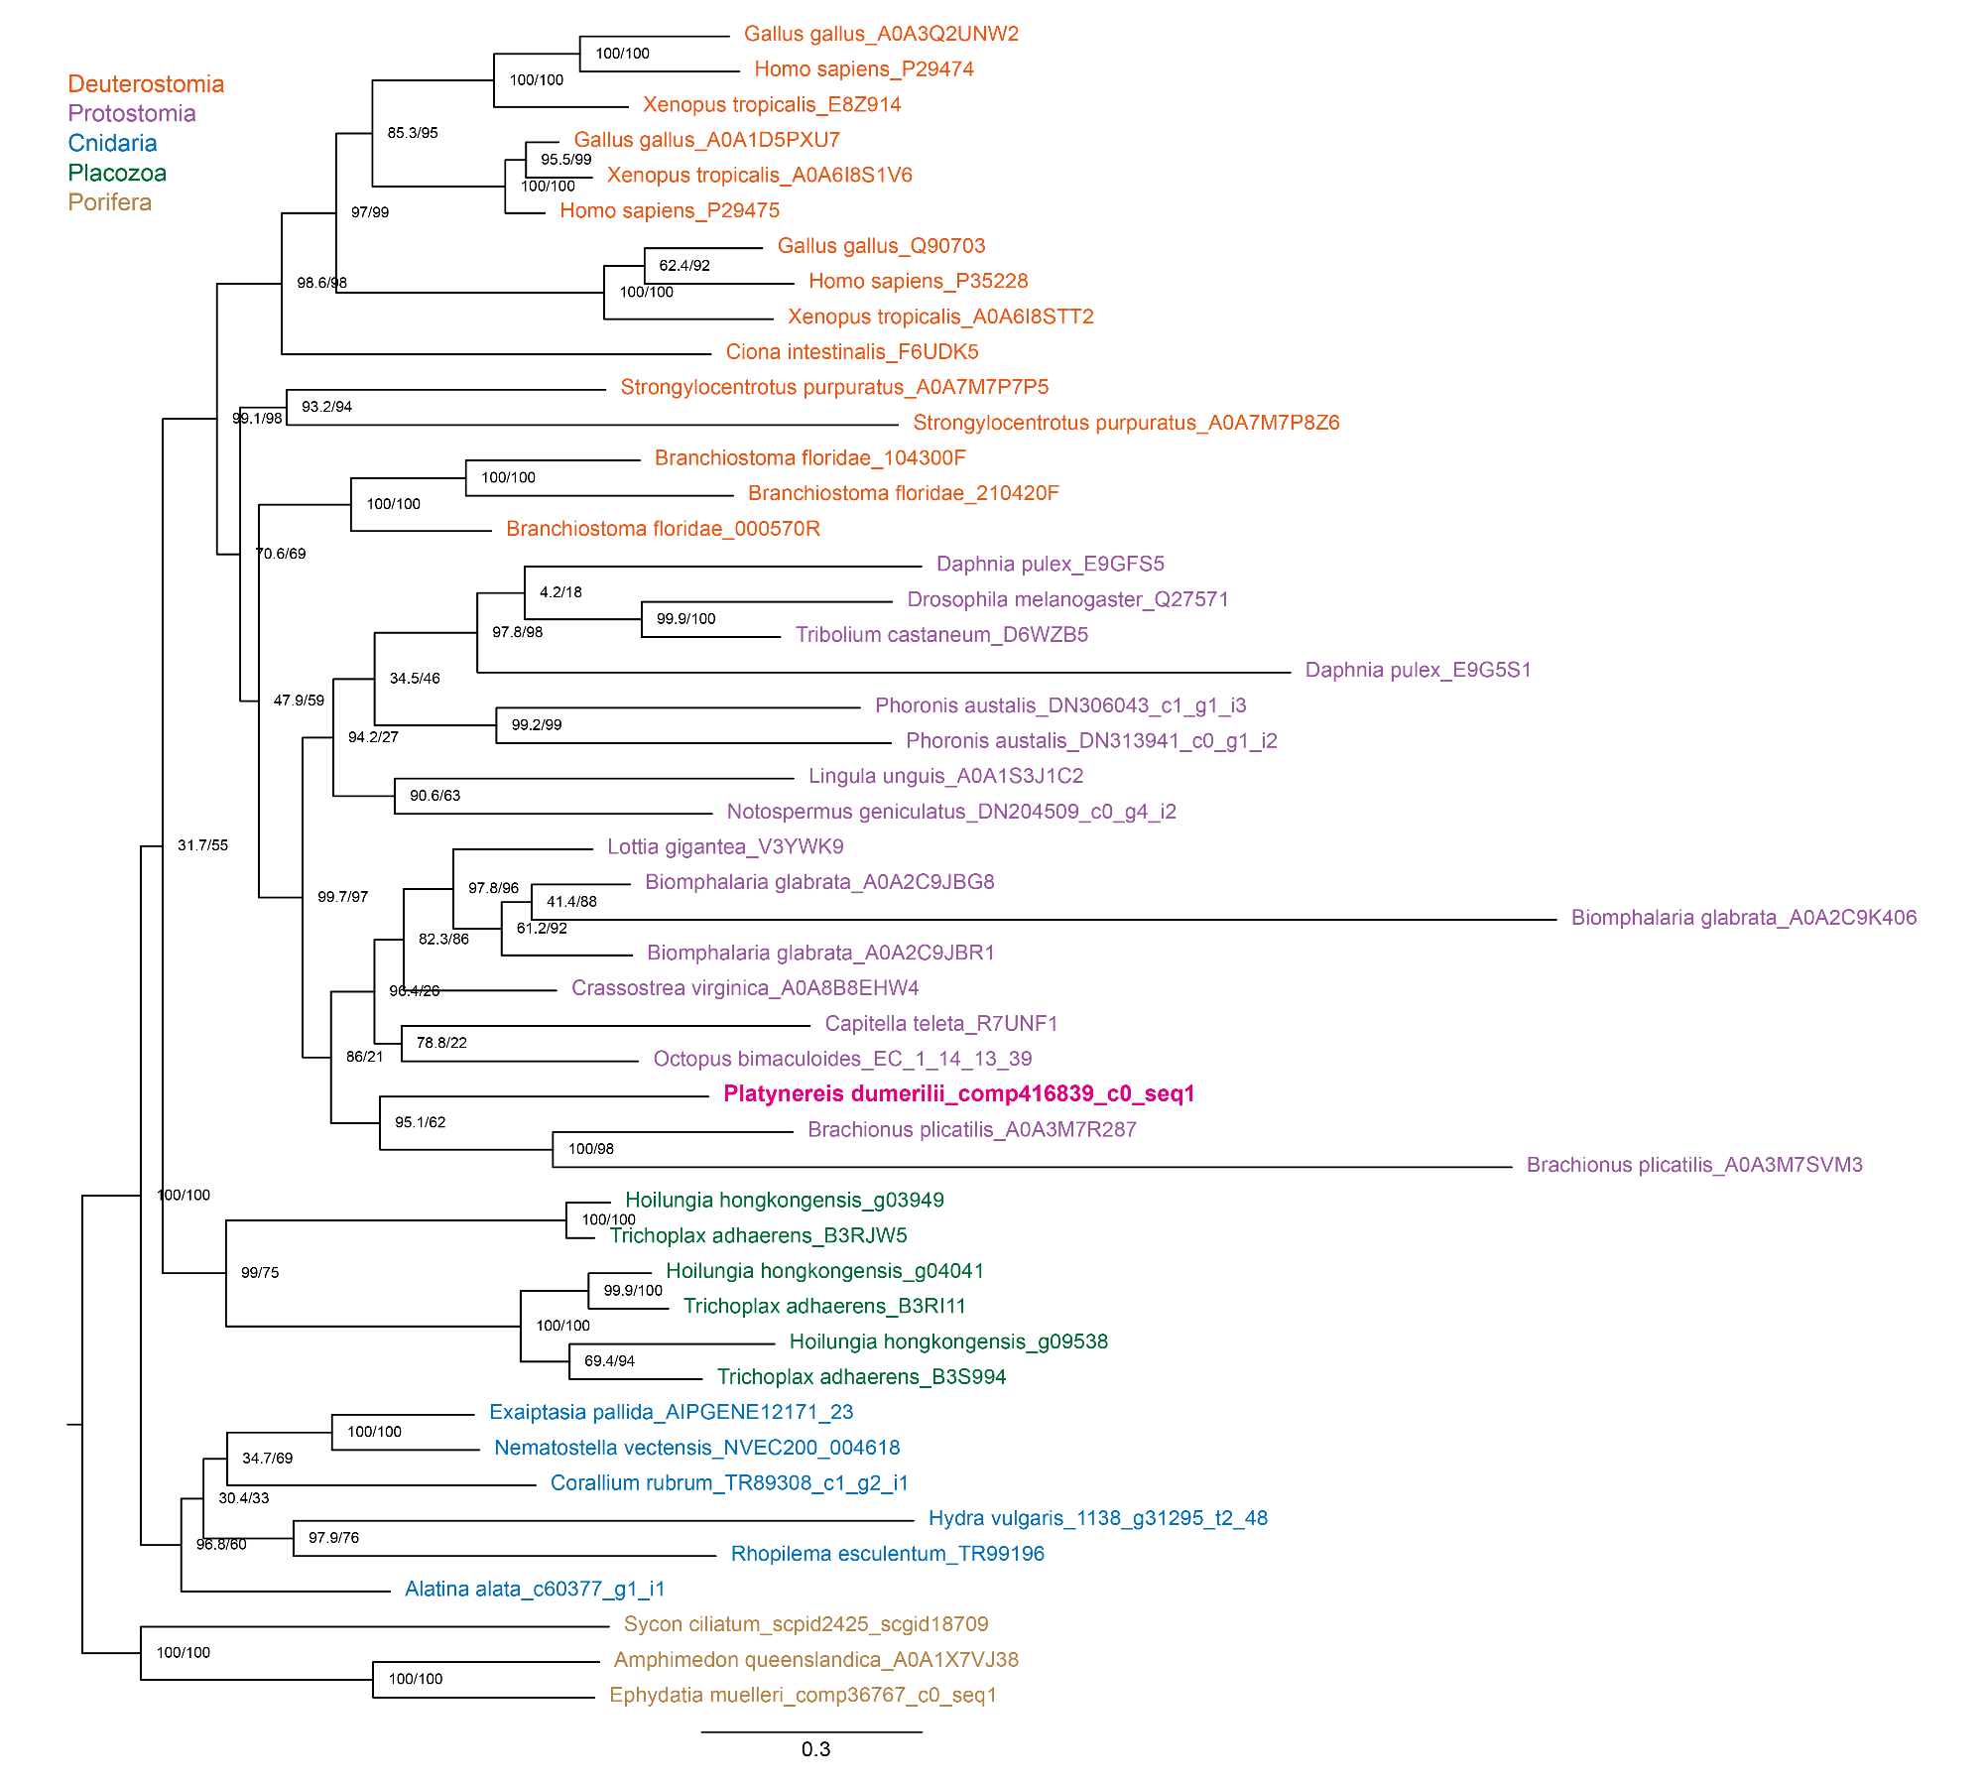

**Figure 1 – figure supplement 1** Phylogenetic tree of NOS by maximum likelihood. Tree robustness was tested with 1000 replicates of ultrafast bootstrap with the aLRT-SH-like and aBayes methods.

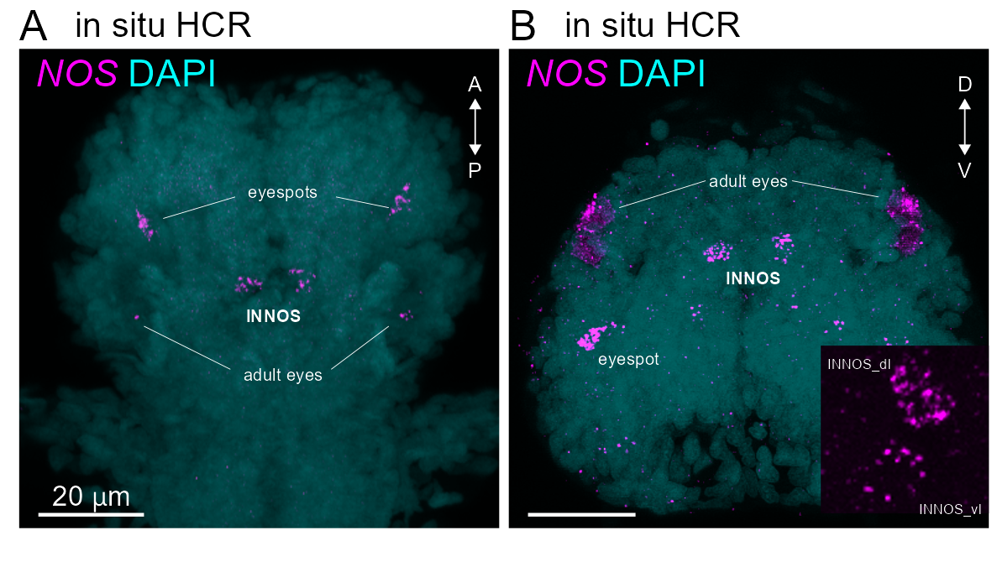

**Figure 1 – figure supplement 2** Expression analysis of the *NOS* gene (magenta) using in situ HCR using the larva at three-day-old in dorsal **(A)** and anterior view (B). (B) Insert: showing two NOS cells (INNOS_dl and INNOS_vl) on left side.

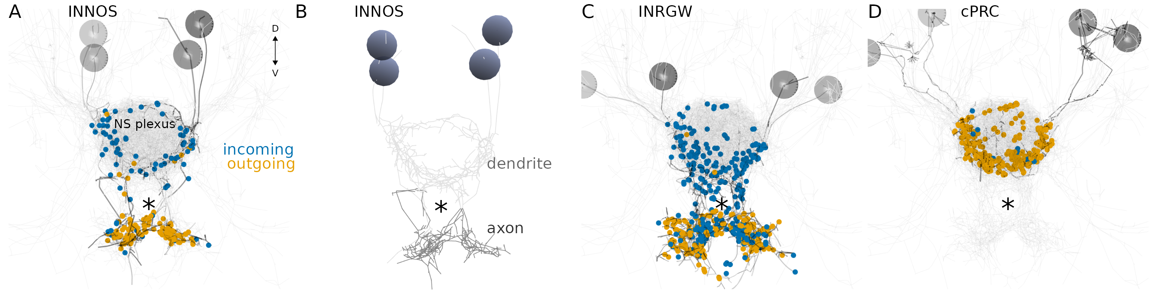

**Figure 1 – figure supplement 3** ssTEM reconstruction of the INNOS (A), INRGWa (B) and cPRC (C), anterior view. NS plexus; neurosecretory plexus

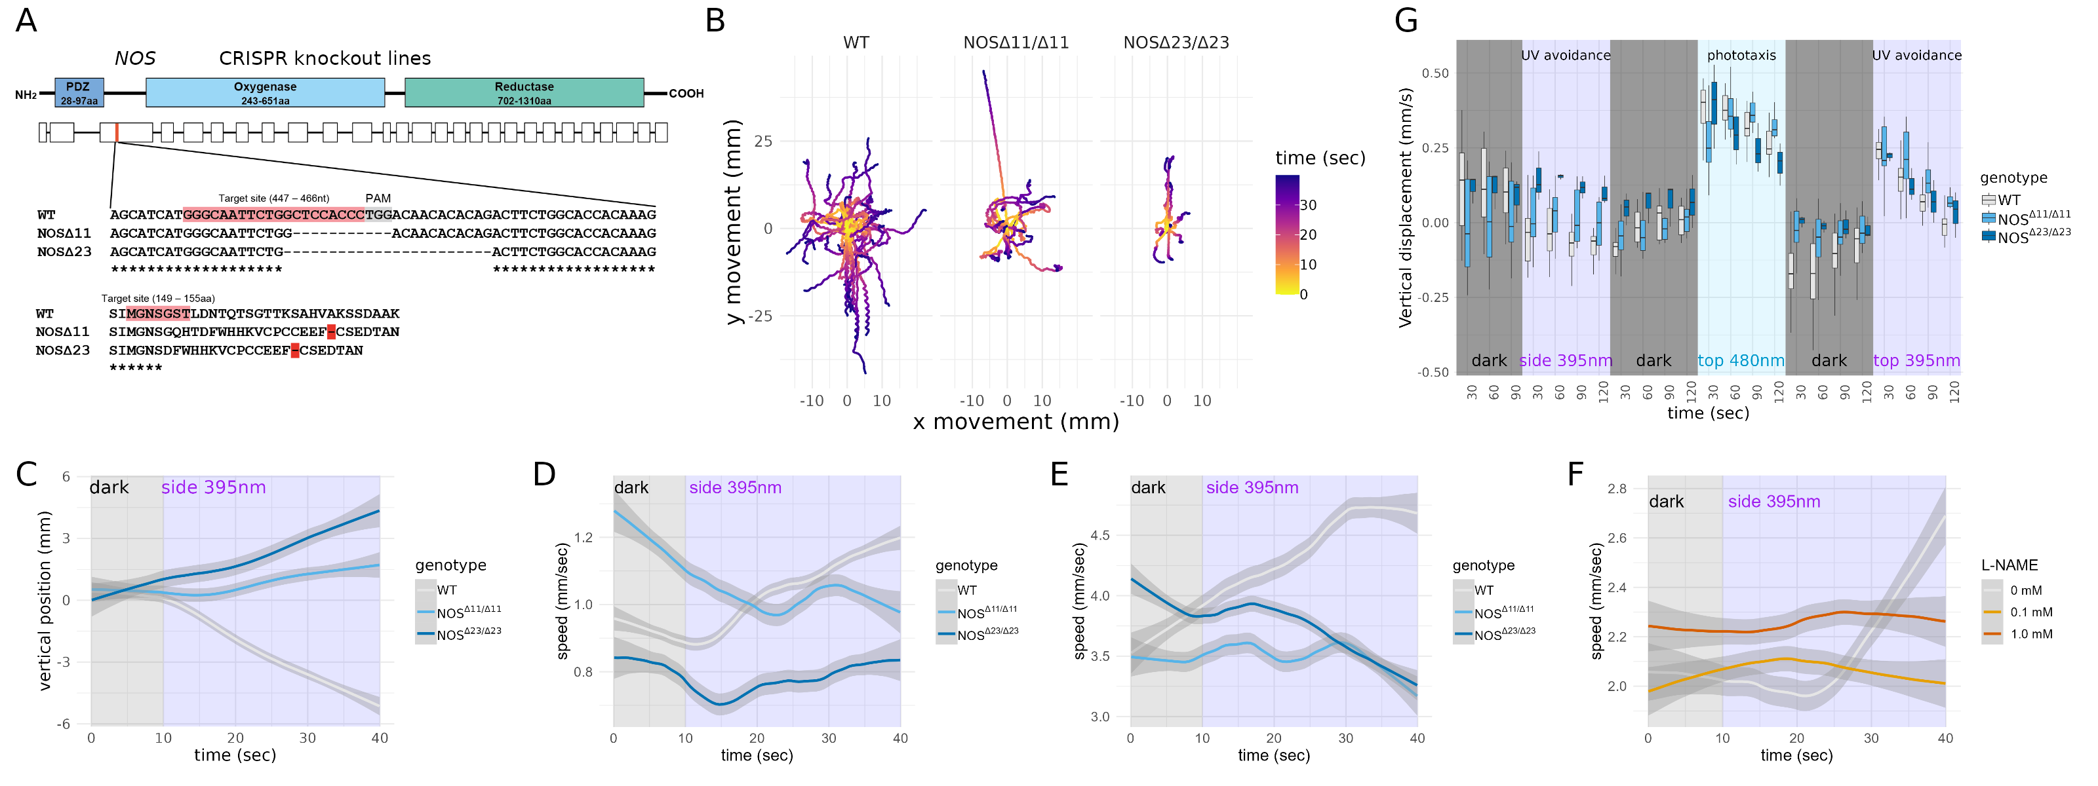

**Figure 3 – figure supplement 1** **(A)** Top: The domain and Exon/Intron structure of NOS. Bottom: Close-up region showing the genomic locus of NOS gene and the wild-type sequence (WT) targeted by CRISPR/Cas9. The generated mutants (NOSΔ11, NOSΔ23) are also shown. Pink indicates target sites. Gray shows PAM sequences, red shows stop codons. **(B)** Overlaid trajectories for WT (n=37) and NOS mutant (NOSΔ11/Δ11, n=18 and NOSΔ23/Δ23, n=8) at two-day-old larvae. 0 sec as the starting point. After 10 sec, UV (395 nm) stimulation from the side. **(C)** The temporal changes in the vertical position of the WT and mutant two-days-old larvae before and after UV stimulation are shown. The starting points of each larval trajectory are set to 0. After UV stimulation is indicated by purple squares. **(D, E)** The temporal changes in the distance traveled of the WT and mutant in two-day (D) and three-day-old (E) larvae before and after UV stimulation are shown. **(F)** The temporal changes in the distance traveled of larvae treated with NOS inhibitors, L-NAME in three-day larvae before and after UV stimulation are shown. **(G)** Vertical swimming in wild-type (WT) and mutant (NOSΔ11 and NOSΔ23) larvae at two-day-old stimulated with UV (395 nm) light from side, blue (488 nm) light from top and UV (395 nm) light from top. The data are shown in 30 s bins.

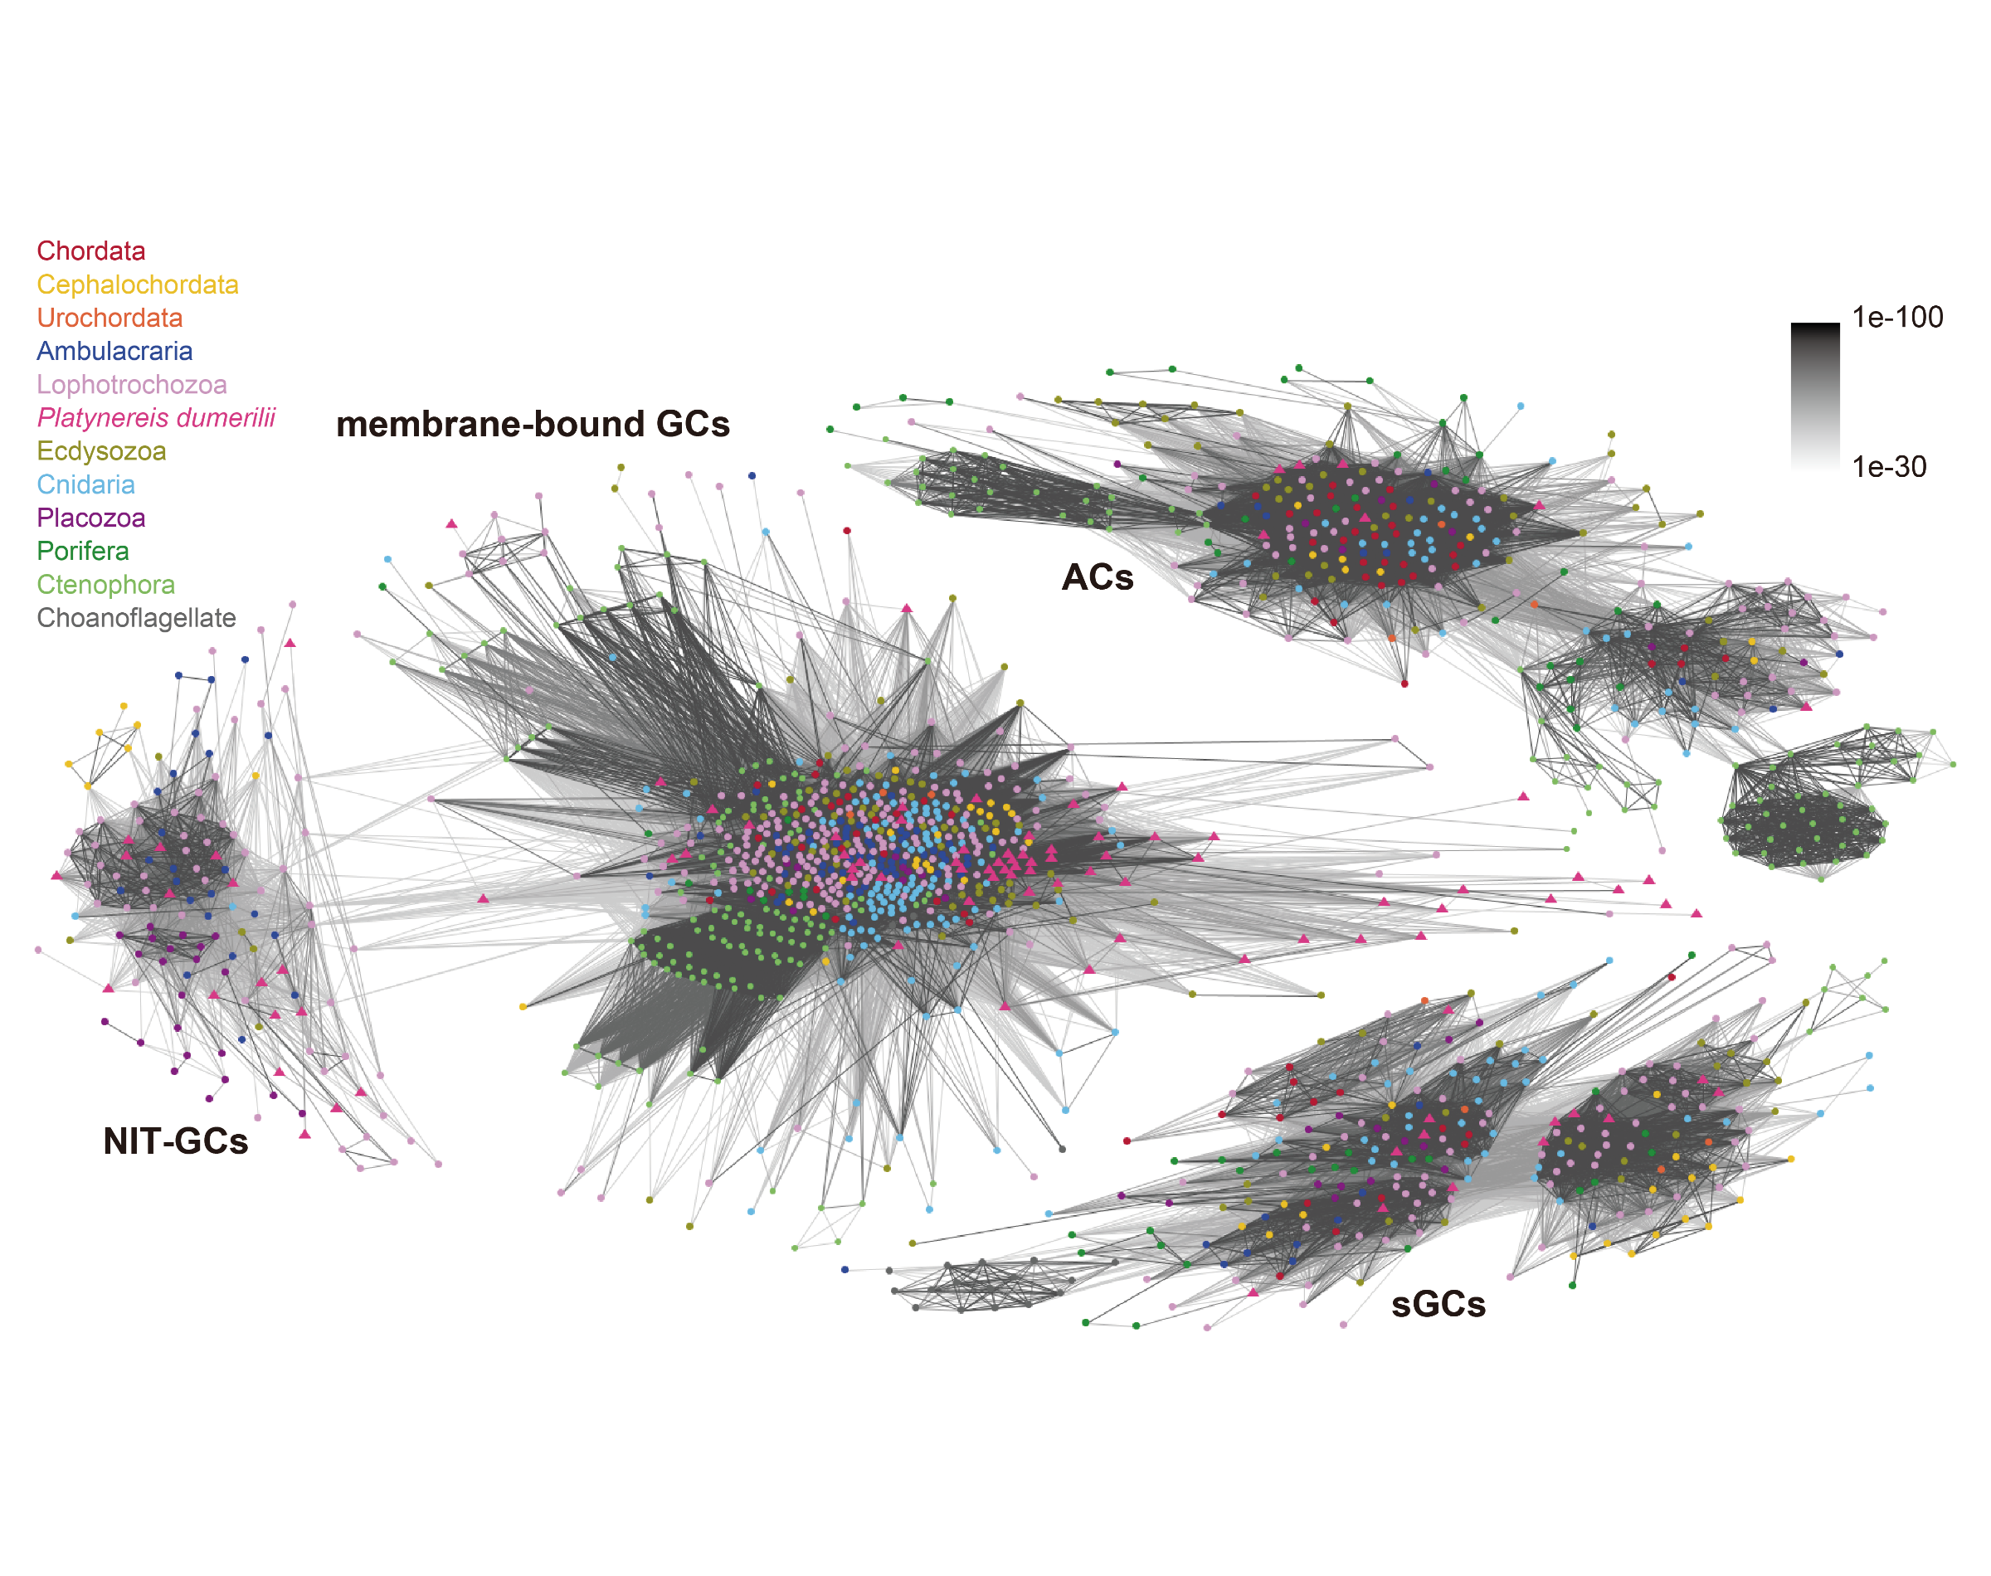

**Figure 4 – figure supplement 1** Cluster analysis of guanylate and adenylate cyclases. Connections are based on blast similarities < 1e-16 as shown on the upper right. Animal groups are colour coded as shown on the upper left. NIT-GCs, NIT domain containing guanylate cyclases; membrane-bound GCs, Membrane-bound guanylyl cyclases; sGCs, soluble guanylate cyclases; ACs, adenylate cyclases.

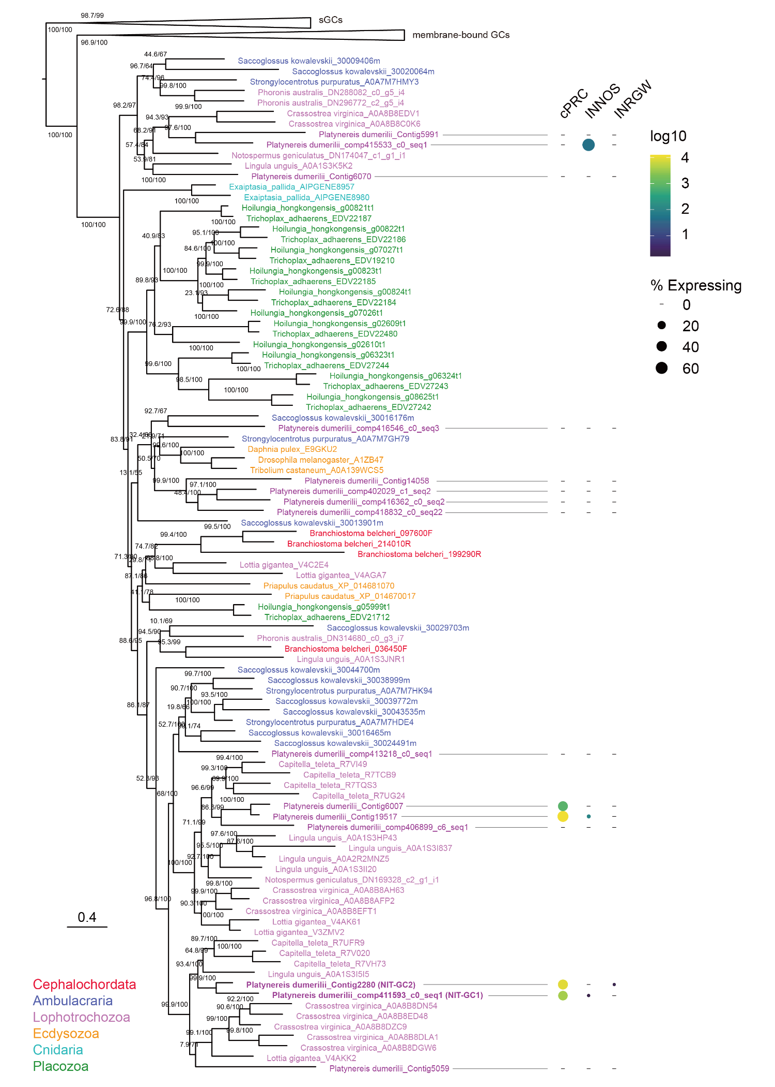

**Figure 4 – figure supplement 2** Phylogenetic tree of guanylate cyclase by maximum likelihood (ML). Guanylate cyclase-coupled receptor and soluble guanylate cyclases (sGC) as outgroups. Guanylate cyclases with NIT domains are found in most animal phyla except Porifera, Ctenophora, Urochordata and Chordata. Dot plot of Platynereis NIT-GC genes (columns) expressed in cPRC, INNOS and INRGWa (rows) using single cell RNA-Seq. The size of the dots is expressed in proportion to the percentage of cells expressing that gene relative to all cells. The colours represent the normal logarithm of the number of transcripts in the cells expressing the gene.

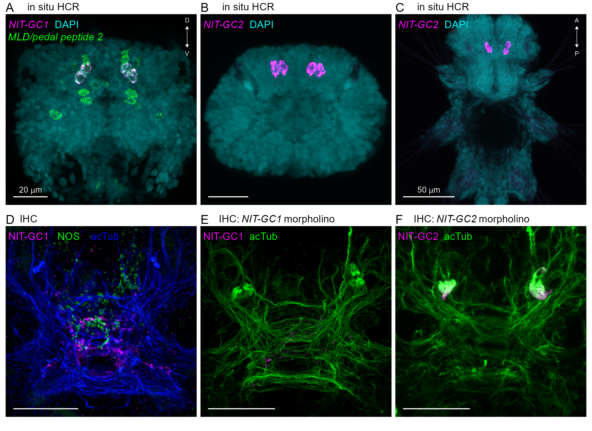

**Figure 4 – figure supplement 3** **(A)** Co-expression analysis image of the NIT-GC1 (magenta) and MLD-pedal2 amide proneuropeptide gene (MLD: green). Anterior view of the larva at two-day-old. **(B, C)** Expression analysis of the NIT-GC2 gene (magenta) using in situ HCR. Anterior (B) and posterior (C) views of the larva at three-day-old. **(D)** Co-localisation analysis using NIT-GC1 (magenta) and NOS (green) antibodies. Anterior view of the larva at two-day-old. **(E, F)** Localisation analysis using NIT-GC1 and NIT-GC2 antibodies for NIT-GC1 (E) and NIT-GC2 (F) morphant. Green shows co-staining with acetylated α-tubulin antibody (acTub). Anterior view of the larva at two-day-old.

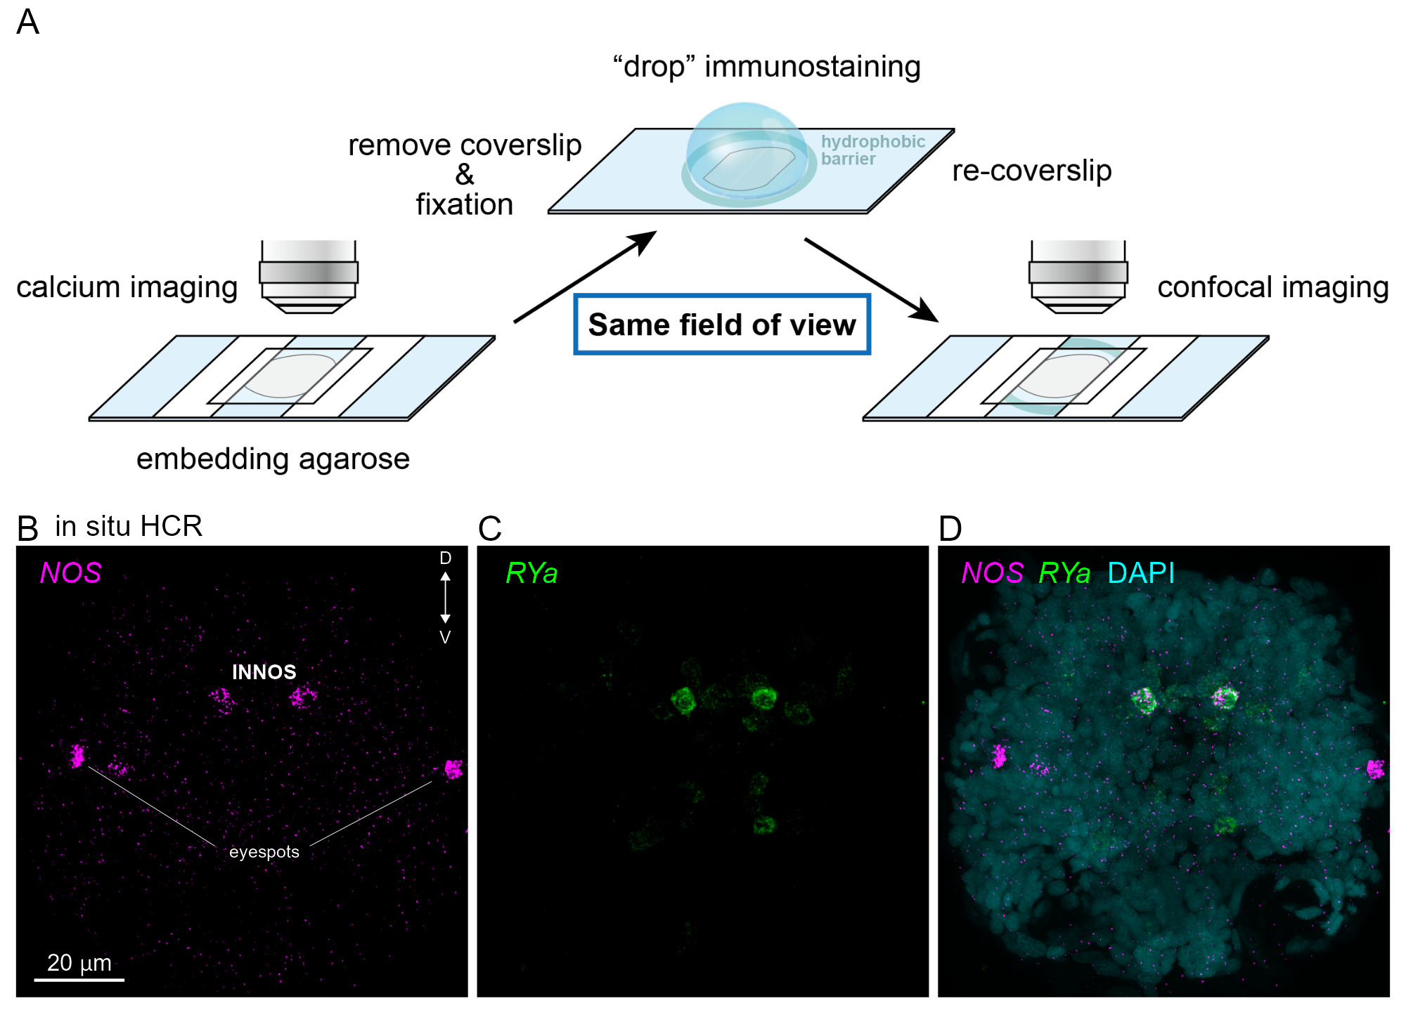

**Figure 5 – figure supplement 1** **(A)** Schematic diagram of the immunostaining procedure after calcium imaging.**(B-D)** Co-expression analysis image of the NOS (magenta) and RY amide proneuropeptide gene (RYa: green). Anterior view of the larva at two-day-old.